AB9 분석

README.txt

$ cd ~/AB9_Demo
$ ./all_run

all_run
./darknet detector demo cfg/coco.data cfg/yolov3.cfg cfg/yolov3.weights

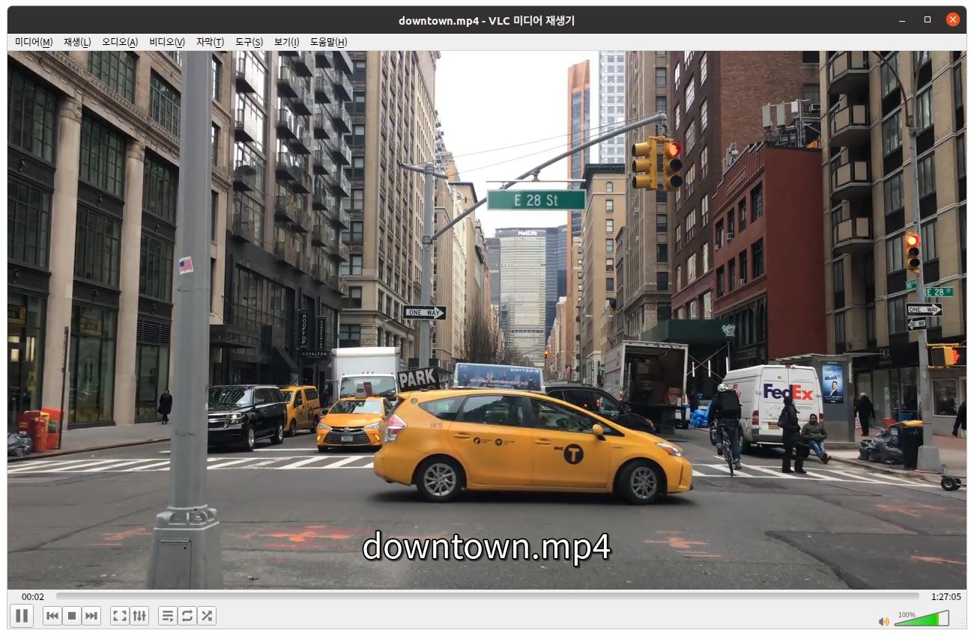 | 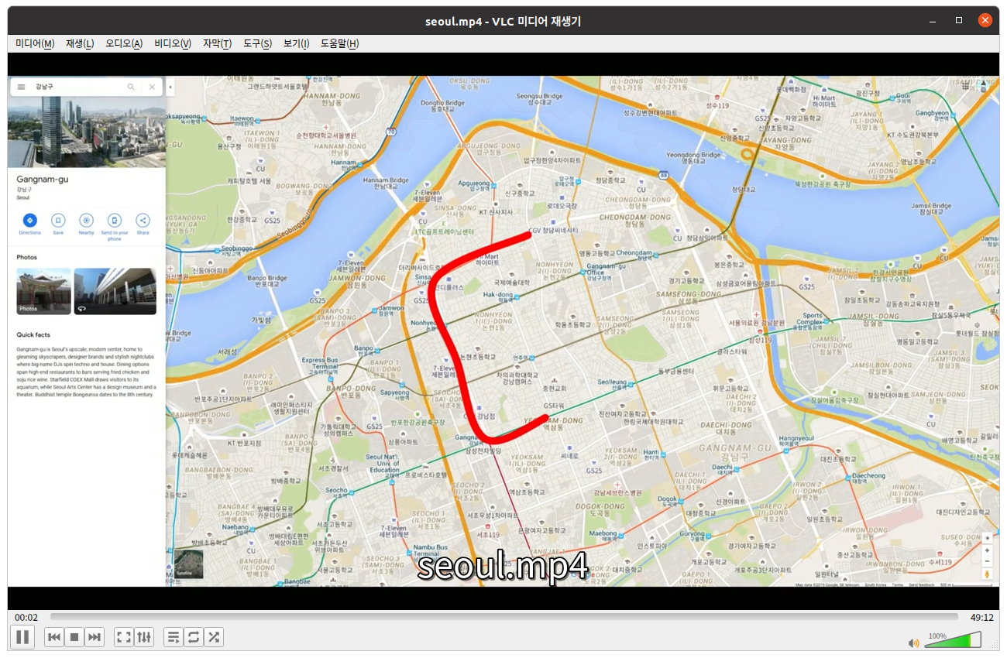
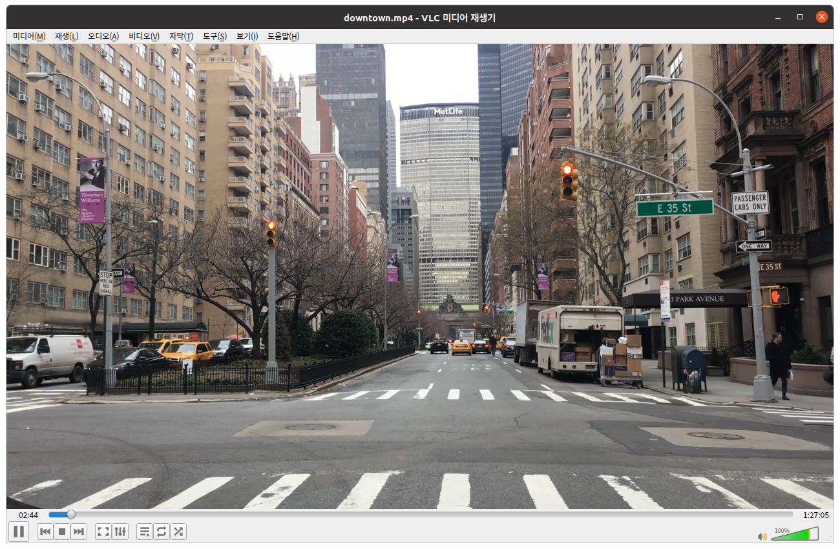 | 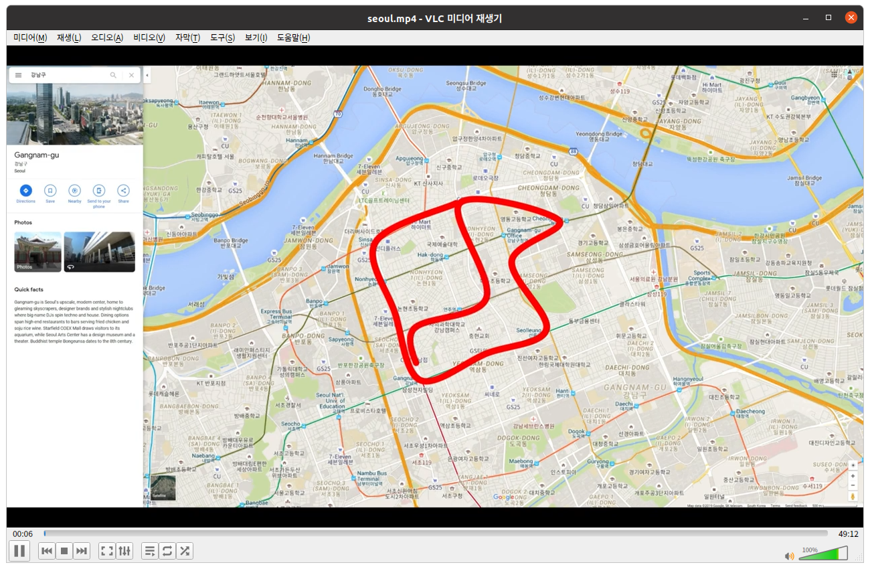
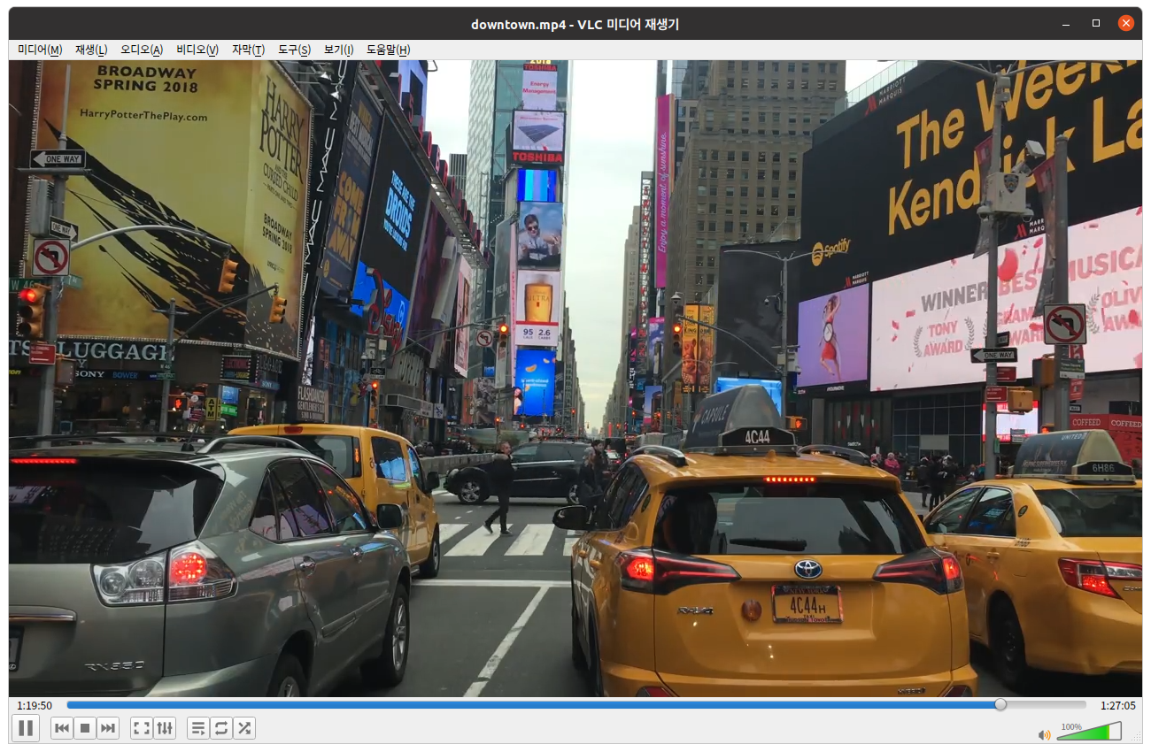 | 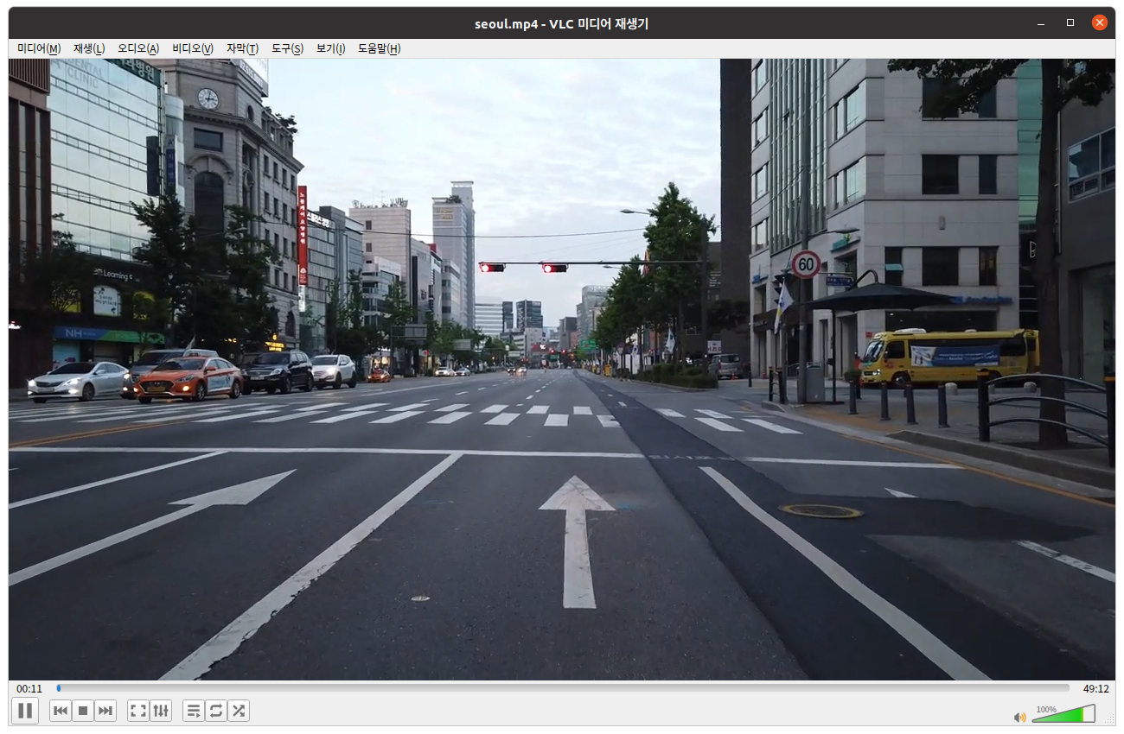

디렉토리 구조
AB9_Demo/
├── cfg
├── data
│ └── labels
├── dumpoutput
├── examples
├── include
├── input
├── obj
├── python
├── reference
├── results
├── scripts
└── src

13 directories

$ cd ~/AB9_Demo
$ ls
LICENSE LICENSE.gpl LICENSE.mit Makefile all_run darknet dumpoutput include libdarknet.a libpldaqpcie_lib.a obj python reset_all scripts
LICENSE.gen LICENSE.meta LICENSE.v1 README.md cfg data examples input libdarknet.so libpldaqpcie_lib.so obj.tar.gz reference results src

매뉴얼에 있던 파일
$ find . -name "*.onnx"
$ find . -name "*.stchw"
./cfg/stcs32t_f16x16.stchw
$ find . -name "*.stccc"
$

$ ./darknet
./darknet: error while loading shared libraries: libopencv_core.so.2.4: cannot open shared object file: No such file or directory
$ ls
LICENSE LICENSE.mit all_run dumpoutput libdarknet.a obj reset_all
LICENSE.gen LICENSE.v1 cfg examples libdarknet.so obj.tar.gz results
LICENSE.gpl Makefile darknet include libpldaqpcie_lib.a python scripts
LICENSE.meta README.md data input libpldaqpcie_lib.so reference src
$

OPENCV = 1

Makefile에 왜 cuda.o가 들어있는가?

OBJ=gemm.o utils.o cuda.o … onnx_parser.o

GPU를 켰을 때 blas_kernels.o가 있는 것은 이해가 되지만...
ifeq ($(GPU), 1)
LDFLAGS+= -lstdc++
OBJ+= … blas_kernels.o ...
endif

darknet.py

from ctypes import *
import math
import random

def sample(probs):
s = sum(probs)
probs = [a/s for a in probs]
r = random.uniform(0, 1)
for i in range(len(probs)):
r = r - probs[i]
if r <= 0:
return i
return len(probs)-1

...

if __name__ == "__main__":
#net = load_net("cfg/densenet201.cfg", "/home/pjreddie/trained/densenet201.weights", 0)
#im = load_image("data/wolf.jpg", 0, 0)
#meta = load_meta("cfg/imagenet1k.data")
#r = classify(net, meta, im)
#print r[:10]
net = load_net("cfg/tiny-yolo.cfg", "tiny-yolo.weights", 0)
meta = load_meta("cfg/coco.data")
r = detect(net, meta, "data/dog.jpg")
print r

proverbot.py
from darknet import *

def predict_tactic(net, s):
prob = 0
d = c_array(c_float, [0.0]*256)
tac = ''
if not len(s):
s = '\n'
for c in s[:-1]:
d[ord(c)] = 1
pred = predict(net, d)
d[ord(c)] = 0
c = s[-1]
while 1:
d[ord(c)] = 1
pred = predict(net, d)
d[ord(c)] = 0
pred = [pred[i] for i in range(256)]
ind = sample(pred)
c = chr(ind)
prob += math.log(pred[ind])
if len(tac) and tac[-1] == '.':
break
tac = tac + c
return (tac, prob)

def predict_tactics(net, s, n):
tacs = []
for i in range(n):
reset_rnn(net)
tacs.append(predict_tactic(net, s))
tacs = sorted(tacs, key=lambda x: -x[1])
return tacs

net = load_net("cfg/coq.test.cfg", "/home/pjreddie/backup/coq.backup", 0)
t = predict_tactics(net, "+++++\n", 10)
print t

부록 가. lscpu 명령어 실행 결과
Architecture: x86_64
CPU op-mode(s): 32-bit, 64-bit
Byte Order: Little Endian
CPU(s): 32
On-line CPU(s) list: 0-31
Thread(s) per core: 2
Core(s) per socket: 8
Socket(s): 2
NUMA node(s): 2
Vendor ID: GenuineIntel
CPU family: 6
Model: 85
Model name: Intel(R) Xeon(R) Silver 4110 CPU @ 2.10GHz
Stepping: 4
CPU MHz: 1023.648
CPU max MHz: 2101.0000
CPU min MHz: 800.0000
BogoMIPS: 4201.81
Virtualization: VT-x
L1d cache: 32K
L1i cache: 32K
L2 cache: 1024K
L3 cache: 11264K
NUMA node0 CPU(s): 0-7,16-23
NUMA node1 CPU(s): 8-15,24-31
Flags: fpu vme de pse tsc msr pae mce cx8 apic sep mtrr pge mca cmov pat pse36 clflush dts acpi mmx fxsr sse sse2 ss ht tm pbe syscall nx pdpe1gb rdtscp lm constant_tsc art arch_perfmon pebs bts rep_good nopl xtopology nonstop_tsc cpuid aperfmperf pni pclmulqdq dtes64 monitor ds_cpl vmx smx est tm2 ssse3 sdbg fma cx16 xtpr pdcm pcid dca sse4_1 sse4_2 x2apic movbe popcnt tsc_deadline_timer aes xsave avx f16c rdrand lahf_lm abm 3dnowprefetch cpuid_fault epb cat_l3 cdp_l3 invpcid_single pti intel_ppin ssbd mba ibrs ibpb stibp tpr_shadow vnmi flexpriority ept vpid fsgsbase tsc_adjust bmi1 hle avx2 smep bmi2 erms invpcid rtm cqm mpx rdt_a avx512f avx512dq rdseed adx smap clflushopt clwb intel_pt avx512cd avx512bw avx512vl xsaveopt xsavec xgetbv1 xsaves cqm_llc cqm_occup_llc cqm_mbm_total cqm_mbm_local dtherm ida arat pln pts pku ospke md_clear flush_l1d

부록 나. Makefile 내용
#############################################################################
#
# Original Darknet Option
#
# GPU : 0 (not use CUDA), 1 (use CUDA)
# CUDNN : 0 (not use CUDNN), 1 (use CUDNN)
# OPENCV : 0 (not use OPENCV), 1 (use OPENCV)
# OPENMP : 0 (not use OPENMP), 1 (use OPENMP)
# DEBUG : 0 (normal mode), 1 (DEBUG mode)
#
GPU = 0
CUDNN = 0
OPENCV = 1
OPENMP = 0
DEBUG = 0

#############################################################################
#
# AB9 Option
#
# AB9 : 0 (not use AB9), 1 (use AB9)
# STC_SREVER : 1 (Xeon mode)
# STCSE_MC : 0 (soc/fpga), 1 (simulation)
# AB9_BIG_ENDIAN : 0 (little endian mode), 1 (big endian mode)
# OUT_DIFF : 0 (not check output), 1 (check output) --- simulation only
# DUMP_OUTPUT : 0 (not dump output), 1 (dump output) --- simulation only
# DDR0_ONLY : 0 (use DDR0/DDR1), 1 (use DDR0 only)
# AIWARE_INTERRUPT : 0 (polling mode), 1 (interrupt mode)
# YOLO_STC_LAYER : 0 (not use YOLO_STC_LAYER), 1 (use YOLO_STC_LAYER)
# CMD_MERGE : 0 (not merge commands), 1 (merge commands)
# NO_WAIT : 0 (not modify waitNcycle), 1 (set waitNcycle to 0)
# ONLY_HALF : 0 (float I/O), 1 (half I/O)
# NO_PG : 0 (original SPG), 1 (no PG = always ON)
#
AB9 = 1
STC_SERVER = 1
STCSE_MC = 0
AB9_BIG_ENDIAN = 1
OUT_DIFF = 0
DUMP_OUTPUT = 0
DDR0_ONLY = 0
AIWARE_INTERRUPT = 1
YOLO_STC_LAYER = 1
CMD_MERGE = 1
NO_WAIT = 1
ONLY_HALF = 1
NO_PG = 0
HALF_ALIGN = 1

LOAD_COMPILEDNN_BINARY = 1
STORE_COMPILEDNN_BINARY = 0

#############################################################################
#
# CompiledNN filename setting
#

ifeq ($(DDR0_ONLY), 1)
YOLOV2_COMPILEDNN="input/CompiledNN_Yolov2_stcs32t_bh128_batch1_ddr0_20200703.h"
else
YOLOV2_COMPILEDNN="input/CompiledNN_Yolov2_stcs32t_bh128.h"
#YOLOV2_COMPILEDNN="input/CompiledNN_Yolov2_stcs32t_bh128_batch1_20200707.h"
endif

ifeq ($(DDR0_ONLY), 1)
YOLOV3_COMPILEDNN="input/CompiledNN_Yolov3_stcs32t_bh128_batch1_ddr0_20200701.h"
else
YOLOV3_COMPILEDNN="input/CompiledNN_Yolov3_stcs32t_bh128_batch1_20200707.h"
endif

ifeq ($(LOAD_COMPILEDNN_BINARY), 1)

ifeq ($(CMD_MERGE), 1)
ifeq ($(NO_WAIT), 1)
ifeq ($(ONLY_HALF), 1)
ifeq ($(NO_PG), 1)
YOLOV3_COMPILEDNN_YOLO_STC_LAYER="input/CompiledNN_Yolov3_stcs32t_bh128_batch1_no_pg_20200720.bin"
else
#YOLOV3_COMPILEDNN_YOLO_STC_LAYER="input/CompiledNN_Yolov3_stcs32t_bh128_merge_nowait.bin"
YOLOV3_COMPILEDNN_YOLO_STC_LAYER="input/CompiledNN_Yolov3_stcs32t_bh128_nowait.bin"
endif
else
YOLOV3_COMPILEDNN_YOLO_STC_LAYER="input/CompiledNN_Yolov3_stcs32t_bh128_batch1_nowait_20200717.bin"
endif
else
YOLOV3_COMPILEDNN_YOLO_STC_LAYER="input/CompiledNN_Yolov3_stcs32t_bh128_batch1_cmd_merge_20200716.bin"
endif
else
YOLOV3_COMPILEDNN_YOLO_STC_LAYER="input/CompiledNN_Yolov3_stcs32t_bh128_batch1_yolo_stc_layer_20200716.bin"
endif

else

ifeq ($(CMD_MERGE), 1)
ifeq ($(NO_WAIT), 1)
ifeq ($(ONLY_HALF), 1)
ifeq ($(NO_PG), 1)
YOLOV3_COMPILEDNN_YOLO_STC_LAYER="input/CompiledNN_Yolov3_stcs32t_bh128_batch1_no_pg_20200720.h"
else
#YOLOV3_COMPILEDNN_YOLO_STC_LAYER="input/CompiledNN_Yolov3_stcs32t_bh128_merge_nowait.h"
YOLOV3_COMPILEDNN_YOLO_STC_LAYER="input/CompiledNN_Yolov3_stcs32t_bh128_nowait.h"
endif
else
YOLOV3_COMPILEDNN_YOLO_STC_LAYER="input/CompiledNN_Yolov3_stcs32t_bh128_batch1_nowait_20200717.h"
endif
else
YOLOV3_COMPILEDNN_YOLO_STC_LAYER="input/CompiledNN_Yolov3_stcs32t_bh128_batch1_cmd_merge_20200716.h"
endif
else
YOLOV3_COMPILEDNN_YOLO_STC_LAYER="input/CompiledNN_Yolov3_stcs32t_bh128_batch1_yolo_stc_layer_20200716.h"
endif

endif

STCCC_INCLUDE_PATH = ../stccc/src
STCSE_MC_INCLUDE_PATH = ../stcse_mc/src
AIWARE_INCLUDE_PATH = ../aiware/include
PLDA_DRV_INCLUDE_PATH = ../plda/driver/include
PLDA_DRIVER_PATH = ../plda/driver
PLDA_INCLUDE_PATH = ../plda/qpcie_api/include
PLDA_LIBRARY_PATH = ../plda/qpcie_api/bin/$(shell uname -m)

ARC0= -gencode arch=compute_30,code=sm_30 \
-gencode arch=compute_35,code=sm_35 \
-gencode arch=compute_50,code=[sm_50,compute_50] \
-gencode arch=compute_52,code=[sm_52,compute_52]
# -gencode arch=compute_20,code=[sm_20,sm_21] \ This one is deprecated?

# This is what I use, uncomment if you know your arch and want to specify
# ARCH= -gencode arch=compute_52,code=compute_52

ifeq ($(STCSE_MC), 1)
VPATH=./src:./examples:../aiware/srcForHost:../stccc/src:../aiware/src:../stcse_mc/src/:../aiware/srcForABC/
else
VPATH=./src:./examples:../aiware/srcForHost:../stccc/src:../aiware/src
endif
SLIB=libdarknet.so
ALIB=libdarknet.a
EXEC=darknet
OBJDIR=./obj/

ifeq ($(shell cat /etc/issue.net | grep CentOS | cut -d' ' -f1), CentOS)
LINUXMACHINE = CENTOS
else
LINUXMACHINE = UBUNTU
endif

CC=gcc
CPP=g++
NVCC=nvcc
AR=ar
ARFLAGS=rcs
#OPTS=-Ofast
LDFLAGS= -lm -lpthread -lrt -mavx
COMMON= -Iinclude/ -Isrc/ -I../aiware/include/ -I../aiware/srcForHost/ -I../aiware/srcForABC/ -I../stcse_mc/src/
CFLAGS=-Wall -Wno-unused-result -Wno-unknown-pragmas -Wfatal-errors -fPIC

CFLAGS+= -DYOLOV2_COMPILEDNN=\"$(YOLOV2_COMPILEDNN)\"
CFLAGS+= -DYOLOV3_COMPILEDNN=\"$(YOLOV3_COMPILEDNN)\"
CFLAGS+= -DYOLOV3_COMPILEDNN_YOLO_STC_LAYER=\"$(YOLOV3_COMPILEDNN_YOLO_STC_LAYER)\"
CFLAGS += -I$(STCCC_INCLUDE_PATH)
CFLAGS += -I$(AIWARE_INCLUDE_PATH)
CFLAGS += -I$(STCSE_MC_INCLUDE_PATH)
CFLAGS += -I$(PLDA_INCLUDE_PATH)

ifeq ($(AB9), 1)
CFLAGS+= -DAB9
LDFLAGS+= -lrt
endif

ifeq ($(LOAD_COMPILEDNN_BINARY), 1)
CFLAGS+= -DLOAD_COMPILEDNN_BINARY
endif

ifeq ($(STORE_COMPILEDNN_BINARY), 1)
CFLAGS+= -DSTORE_COMPILEDNN_BINARY
endif

ifeq ($(STCSE_MC), 1)
CFLAGS+= -DSTCSE_MC
LDFLAGS+= -lrt
endif

ifeq ($(AB9_BIG_ENDIAN), 1)
CFLAGS+= -DAB9_BIG_ENDIAN
endif

ifeq ($(AB9_DIFF), 1)
CFLAGS+= -DAB9_DIFF
endif

ifeq ($(DUMP_OUTPUT), 1)
CFLAGS += -DDUMP_OUTPUT
endif

ifeq ($(OUT_DIFF), 1)
CFLAGS += -DOUT_DIFF
endif

ifeq ($(STC_SERVER), 1)
CFLAGS+= -DSTC_SERVER -DEXCEPT_STCCC_MAIN
endif

ifeq ($(DDR0_ONLY), 1)
CFLAGS+= -DSTC_KERNEL_BASE=0x110000000
endif

ifeq ($(AIWARE_INTERRUPT), 1)
CFLAGS+= -DAIWARE_INTERRUPT
endif

ifeq ($(YOLO_STC_LAYER), 1)
CFLAGS+= -DYOLO_STC_LAYER
endif

ifeq ($(ONLY_HALF), 1)
CFLAGS+= -DONLY_HALF
endif

CFLAGS+= -DHALF_ALIGN=$(HALF_ALIGN)

ifeq ($(OPENMP), 1)
CFLAGS+= -fopenmp
endif

ifeq ($(DEBUG), 1)
OPTS=-O0 -g
endif

CFLAGS+=$(OPTS) -D$(LINUXMACHINE)

ifeq ($(OPENCV), 1)
COMMON+= -DOPENCV
CFLAGS+= -DOPENCV
LDFLAGS+= `pkg-config --libs opencv` -lstdc++
COMMON+= `pkg-config --cflags opencv`
endif

ifeq ($(GPU), 1)
COMMON+= -DGPU -I/usr/local/cuda/include/
CFLAGS+= -DGPU
LDFLAGS+= -L/usr/local/cuda/lib64 -lcuda -lcudart -lcublas -lcurand
endif

ifeq ($(CUDNN), 1)
COMMON+= -DCUDNN
CFLAGS+= -DCUDNN
LDFLAGS+= -lcudnn
endif

OBJ=gemm.o utils.o cuda.o deconvolutional_layer.o convolutional_layer.o list.o image.o activations.o im2col.o col2im.o blas.o crop_layer.o dropout_layer.o maxpool_layer.o softmax_layer.o data.o matrix.o network.o connected_layer.o cost_layer.o parser.o option_list.o detection_layer.o route_layer.o upsample_layer.o box.o normalization_layer.o avgpool_layer.o layer.o local_layer.o shortcut_layer.o logistic_layer.o activation_layer.o rnn_layer.o gru_layer.o crnn_layer.o demo.o batchnorm_layer.o region_layer.o reorg_layer.o tree.o lstm_layer.o l2norm_layer.o yolo_layer.o iseg_layer.o image_opencv.o stccc.o stccc_frontend.o ddralloc.o setparams.o writecmd.o agp.o dcassign.o mmp.o nccmdp.o pwrgate.o aiwareif.o aiwareHost.o forward_network_AB9.o onnx_parser.o

ifeq ($(STCSE_MC), 1)
OBJ+=stcse_mc.o aiwareAbc.o
endif

EXECOBJA=captcha.o lsd.o super.o art.o tag.o cifar.o go.o rnn.o segmenter.o regressor.o classifier.o coco.o yolo.o detector.o nightmare.o instance-segmenter.o darknet.o
ifeq ($(GPU), 1)
LDFLAGS+= -lstdc++
OBJ+=convolutional_kernels.o deconvolutional_kernels.o activation_kernels.o im2col_kernels.o col2im_kernels.o blas_kernels.o crop_layer_kernels.o dropout_layer_kernels.o maxpool_layer_kernels.o avgpool_layer_kernels.o
endif

EXECOBJ = $(addprefix $(OBJDIR), $(EXECOBJA))
OBJS = $(addprefix $(OBJDIR), $(OBJ))
DEPS = $(wildcard src/*.h) Makefile include/darknet.h

ifeq ($(shell cat /etc/issue.net | grep CentOS | cut -d' ' -f1), CentOS)
STDC11 = -std=c++0x
else
STDC11 = -std=c++11
endif

all: obj results $(SLIB) $(ALIB) $(EXEC)
#all: obj results $(SLIB) $(ALIB) $(EXEC)

$(EXEC): $(EXECOBJ) $(ALIB)
$(CPP) $(COMMON) $(CFLAGS) -D$(LINUXMACHINE) -I$(AIWARE_INCLUDE_PATH) -I$(PLDA_INCLUDE_PATH) -I$(PLDA_DRIVER_PATH)/include $^ -o $@ -L$(PLDA_LIBRARY_PATH) $(LDFLAGS) $(ALIB) libpldaqpcie_lib.a -lrt

$(ALIB): $(OBJS)
$(AR) $(ARFLAGS) $@ $^

$(SLIB): $(OBJS)
$(CC) $(CFLAGS) -shared $^ -o $@ $(LDFLAGS)

$(OBJDIR)%.o: %.cpp $(DEPS)
$(CPP) $(COMMON) $(CFLAGS) $(STDC11) -I$(AIWARE_INCLUDE_PATH) -I$(PLDA_INCLUDE_PATH) -I$(PLDA_DRV_INCLUDE_PATH) -c $< -o $@

$(OBJDIR)%.o: %.c $(DEPS)
$(CC) $(COMMON) $(CFLAGS) -I$(AIWARE_INCLUDE_PATH) -I$(PLDA_INCLUDE_PATH) -I$(PLDA_DRV_INCLUDE_PATH) -c $< -o $@

$(OBJDIR)%.o: %.cu $(DEPS)
$(NVCC) $(ARCH) $(COMMON) --compiler-options "$(CFLAGS)" -c $< -o $@

obj:
mkdir -p obj
results:
mkdir -p results

.PHONY: clean

clean:
rm -rf $(OBJS) $(SLIB) $(ALIB) $(EXEC) $(EXECOBJ) $(OBJDIR)/*

부록 다. Lshw 명령어 실행 결과
etri
description: Computer
product: SYS-7049GP-TRT (To be filled by O.E.M.)
vendor: Supermicro
version: 0123456789
serial: A291427X0909142
width: 64 bits
capabilities: smbios-3.2 dmi-3.2 vsyscall32
configuration: boot=normal family=To be filled by O.E.M. sku=To be filled by O.E.M. uuid=00F632A7-CA2D-EA11-8000-AC1F6BFEBF68
*-core
description: Motherboard
product: X11DPG-QT
vendor: Supermicro
physical id: 0
version: 1.10A
serial: UM19CS010633
slot: To be filled by O.E.M.
*-firmware
description: BIOS
vendor: American Megatrends Inc.
physical id: 1
version: 3.3
date: 02/21/2020
size: 64KiB
capacity: 15MiB
capabilities: pci upgrade shadowing cdboot bootselect socketedrom edd int13floppy1200 int13floppy720 int13floppy2880 int5printscreen int14serial int17printer acpi usb biosbootspecification uefi
*-memory:0
description: System Memory
physical id: 26
slot: System board or motherboard
*-bank:0
description: DIMM Synchronous 2666 MHz (0.4 ns)
product: M393A2K43CB2-CTD
vendor: Samsung
physical id: 0
serial: 443B289B
slot: P1-DIMMA1
size: 16GiB
width: 64 bits
clock: 2666MHz (0.4ns)
*-bank:1
description: DIMM Synchronous 2666 MHz (0.4 ns)
product: M393A2K43CB2-CTD
vendor: Samsung
physical id: 1
serial: 443B28AE
slot: P1-DIMMA2
size: 16GiB
width: 64 bits
clock: 2666MHz (0.4ns)
*-bank:2
description: DIMM [empty]
product: NO DIMM
vendor: NO DIMM
physical id: 2
serial: NO DIMM
slot: P1-DIMMB1
*-bank:3
description: DIMM [empty]
product: NO DIMM
vendor: NO DIMM
physical id: 3
serial: NO DIMM
slot: P1-DIMMC1
*-memory:1
description: System Memory
physical id: 2e
slot: System board or motherboard
*-bank:0
description: DIMM Synchronous 2666 MHz (0.4 ns)
product: M393A2K43CB2-CTD
vendor: Samsung
physical id: 0
serial: 443B287F
slot: P1-DIMMD1
size: 16GiB
width: 64 bits
clock: 2666MHz (0.4ns)
*-bank:1
description: DIMM Synchronous 2666 MHz (0.4 ns)
product: M393A2K43CB2-CTD
vendor: Samsung
physical id: 1
serial: 443B2D4D
slot: P1-DIMMD2
size: 16GiB
width: 64 bits
clock: 2666MHz (0.4ns)
*-bank:2
description: DIMM [empty]
product: NO DIMM
vendor: NO DIMM
physical id: 2
serial: NO DIMM
slot: P1-DIMME1
*-bank:3
description: DIMM [empty]
product: NO DIMM
vendor: NO DIMM
physical id: 3
serial: NO DIMM
slot: P1-DIMMF1
*-memory:2
description: System Memory
physical id: 36
slot: System board or motherboard
*-bank:0
description: DIMM Synchronous 2666 MHz (0.4 ns)
product: M393A2K43CB2-CTD
vendor: Samsung
physical id: 0
serial: 443B28B6
slot: P2-DIMMA1
size: 16GiB
width: 64 bits
clock: 2666MHz (0.4ns)
*-bank:1
description: DIMM Synchronous 2666 MHz (0.4 ns)
product: M393A2K43CB2-CTD
vendor: Samsung
physical id: 1
serial: 443B2D3A
slot: P2-DIMMA2
size: 16GiB
width: 64 bits
clock: 2666MHz (0.4ns)
*-bank:2
description: DIMM [empty]
product: NO DIMM
vendor: NO DIMM
physical id: 2
serial: NO DIMM
slot: P2-DIMMB1
*-bank:3
description: DIMM [empty]
product: NO DIMM
vendor: NO DIMM
physical id: 3
serial: NO DIMM
slot: P2-DIMMC1
*-memory:3
description: System Memory
physical id: 3e
slot: System board or motherboard
*-bank:0
description: DIMM Synchronous 2666 MHz (0.4 ns)
product: M393A2K43CB2-CTD
vendor: Samsung
physical id: 0
serial: 443B28C2
slot: P2-DIMMD1
size: 16GiB
width: 64 bits
clock: 2666MHz (0.4ns)
*-bank:1
description: DIMM Synchronous 2666 MHz (0.4 ns)
product: M393A2K43CB2-CTD
vendor: Samsung
physical id: 1
serial: 443B2201
slot: P2-DIMMD2
size: 16GiB
width: 64 bits
clock: 2666MHz (0.4ns)
*-bank:2
description: DIMM [empty]
product: NO DIMM
vendor: NO DIMM
physical id: 2
serial: NO DIMM
slot: P2-DIMME1
*-bank:3
description: DIMM [empty]
product: NO DIMM
vendor: NO DIMM
physical id: 3
serial: NO DIMM
slot: P2-DIMMF1
*-cache:0
description: L1 cache
physical id: 53
slot: L1 Cache
size: 512KiB
capacity: 512KiB
capabilities: synchronous internal write-back instruction
configuration: level=1
*-cache:1
description: L2 cache
physical id: 54
slot: L2 Cache
size: 8MiB
capacity: 8MiB
capabilities: synchronous internal varies unified
configuration: level=2
*-cache:2
description: L3 cache
physical id: 55
slot: L3 Cache
size: 11MiB
capacity: 11MiB
capabilities: synchronous internal varies unified
configuration: level=3
*-cpu:0
description: CPU
product: Intel(R) Xeon(R) Silver 4110 CPU @ 2.10GHz
vendor: Intel Corp.
physical id: 56
bus info: cpu@0
version: Intel(R) Xeon(R) Silver 4110 CPU @ 2.10GHz
slot: CPU1
size: 830MHz
capacity: 2101MHz
width: 64 bits
clock: 100MHz
capabilities: x86-64 fpu fpu_exception wp vme de pse tsc msr pae mce cx8 apic sep mtrr pge mca cmov pat pse36 clflush dts acpi mmx fxsr sse sse2 ss ht tm pbe syscall nx pdpe1gb rdtscp constant_tsc art arch_perfmon pebs bts rep_good nopl xtopology nonstop_tsc cpuid aperfmperf pni pclmulqdq dtes64 monitor ds_cpl vmx smx est tm2 ssse3 sdbg fma cx16 xtpr pdcm pcid dca sse4_1 sse4_2 x2apic movbe popcnt tsc_deadline_timer aes xsave avx f16c rdrand lahf_lm abm 3dnowprefetch cpuid_fault epb cat_l3 cdp_l3 invpcid_single pti intel_ppin ssbd mba ibrs ibpb stibp tpr_shadow vnmi flexpriority ept vpid fsgsbase tsc_adjust bmi1 hle avx2 smep bmi2 erms invpcid rtm cqm mpx rdt_a avx512f avx512dq rdseed adx smap clflushopt clwb intel_pt avx512cd avx512bw avx512vl xsaveopt xsavec xgetbv1 xsaves cqm_llc cqm_occup_llc cqm_mbm_total cqm_mbm_local dtherm ida arat pln pts pku ospke md_clear flush_l1d cpufreq
configuration: cores=8 enabledcores=8 threads=16
*-cache:3
description: L1 cache
physical id: 57
slot: L1 Cache
size: 512KiB
capacity: 512KiB
capabilities: synchronous internal write-back instruction
configuration: level=1
*-cache:4
description: L2 cache
physical id: 58
slot: L2 Cache
size: 8MiB
capacity: 8MiB
capabilities: synchronous internal varies unified
configuration: level=2
*-cache:5
description: L3 cache
physical id: 59
slot: L3 Cache
size: 11MiB
capacity: 11MiB
capabilities: synchronous internal varies unified
configuration: level=3
*-cpu:1
description: CPU
product: Intel(R) Xeon(R) Silver 4110 CPU @ 2.10GHz
vendor: Intel Corp.
physical id: 5a
bus info: cpu@1
version: Intel(R) Xeon(R) Silver 4110 CPU @ 2.10GHz
slot: CPU2
size: 2100MHz
capacity: 2101MHz
width: 64 bits
clock: 100MHz
capabilities: x86-64 fpu fpu_exception wp vme de pse tsc msr pae mce cx8 apic sep mtrr pge mca cmov pat pse36 clflush dts acpi mmx fxsr sse sse2 ss ht tm pbe syscall nx pdpe1gb rdtscp constant_tsc art arch_perfmon pebs bts rep_good nopl xtopology nonstop_tsc cpuid aperfmperf pni pclmulqdq dtes64 monitor ds_cpl vmx smx est tm2 ssse3 sdbg fma cx16 xtpr pdcm pcid dca sse4_1 sse4_2 x2apic movbe popcnt tsc_deadline_timer aes xsave avx f16c rdrand lahf_lm abm 3dnowprefetch cpuid_fault epb cat_l3 cdp_l3 invpcid_single pti intel_ppin ssbd mba ibrs ibpb stibp tpr_shadow vnmi flexpriority ept vpid fsgsbase tsc_adjust bmi1 hle avx2 smep bmi2 erms invpcid rtm cqm mpx rdt_a avx512f avx512dq rdseed adx smap clflushopt clwb intel_pt avx512cd avx512bw avx512vl xsaveopt xsavec xgetbv1 xsaves cqm_llc cqm_occup_llc cqm_mbm_total cqm_mbm_local dtherm ida arat pln pts pku ospke md_clear flush_l1d cpufreq
configuration: cores=8 enabledcores=8 threads=16
*-memory:4 UNCLAIMED
physical id: 2
*-memory:5 UNCLAIMED
physical id: 3
*-pci:0
description: Host bridge
product: Sky Lake-E DMI3 Registers
vendor: Intel Corporation
physical id: 100
bus info: pci@0000:00:00.0
version: 04
width: 32 bits
clock: 33MHz
*-generic:0
description: System peripheral
product: Sky Lake-E CBDMA Registers
vendor: Intel Corporation
physical id: 4
bus info: pci@0000:00:04.0
version: 04
width: 64 bits
clock: 33MHz
capabilities: msix pciexpress pm bus_master cap_list
configuration: driver=ioatdma latency=0
resources: iomemory:383f0-383ef irq:102 memory:383ffff30000-383ffff33fff
*-generic:1
description: System peripheral
product: Sky Lake-E CBDMA Registers
vendor: Intel Corporation
physical id: 4.1
bus info: pci@0000:00:04.1
version: 04
width: 64 bits
clock: 33MHz
capabilities: msix pciexpress pm bus_master cap_list
configuration: driver=ioatdma latency=0
resources: iomemory:383f0-383ef irq:112 memory:383ffff2c000-383ffff2ffff
*-generic:2
description: System peripheral
product: Sky Lake-E CBDMA Registers
vendor: Intel Corporation
physical id: 4.2
bus info: pci@0000:00:04.2
version: 04
width: 64 bits
clock: 33MHz
capabilities: msix pciexpress pm bus_master cap_list
configuration: driver=ioatdma latency=0
resources: iomemory:383f0-383ef irq:102 memory:383ffff28000-383ffff2bfff
*-generic:3
description: System peripheral
product: Sky Lake-E CBDMA Registers
vendor: Intel Corporation
physical id: 4.3
bus info: pci@0000:00:04.3
version: 04
width: 64 bits
clock: 33MHz
capabilities: msix pciexpress pm bus_master cap_list
configuration: driver=ioatdma latency=0
resources: iomemory:383f0-383ef irq:112 memory:383ffff24000-383ffff27fff
*-generic:4
description: System peripheral
product: Sky Lake-E CBDMA Registers
vendor: Intel Corporation
physical id: 4.4
bus info: pci@0000:00:04.4
version: 04
width: 64 bits
clock: 33MHz
capabilities: msix pciexpress pm bus_master cap_list
configuration: driver=ioatdma latency=0
resources: iomemory:383f0-383ef irq:102 memory:383ffff20000-383ffff23fff
*-generic:5
description: System peripheral
product: Sky Lake-E CBDMA Registers
vendor: Intel Corporation
physical id: 4.5
bus info: pci@0000:00:04.5
version: 04
width: 64 bits
clock: 33MHz
capabilities: msix pciexpress pm bus_master cap_list
configuration: driver=ioatdma latency=0
resources: iomemory:383f0-383ef irq:112 memory:383ffff1c000-383ffff1ffff
*-generic:6
description: System peripheral
product: Sky Lake-E CBDMA Registers
vendor: Intel Corporation
physical id: 4.6
bus info: pci@0000:00:04.6
version: 04
width: 64 bits
clock: 33MHz
capabilities: msix pciexpress pm bus_master cap_list
configuration: driver=ioatdma latency=0
resources: iomemory:383f0-383ef irq:102 memory:383ffff18000-383ffff1bfff
*-generic:7
description: System peripheral
product: Sky Lake-E CBDMA Registers
vendor: Intel Corporation
physical id: 4.7
bus info: pci@0000:00:04.7
version: 04
width: 64 bits
clock: 33MHz
capabilities: msix pciexpress pm bus_master cap_list
configuration: driver=ioatdma latency=0
resources: iomemory:383f0-383ef irq:112 memory:383ffff14000-383ffff17fff
*-generic:8 UNCLAIMED
description: System peripheral
product: Sky Lake-E MM/Vt-d Configuration Registers
vendor: Intel Corporation
physical id: 5
bus info: pci@0000:00:05.0
version: 04
width: 32 bits
clock: 33MHz
capabilities: pciexpress cap_list
configuration: latency=0
*-generic:9 UNCLAIMED
description: System peripheral
product: Intel Corporation
vendor: Intel Corporation
physical id: 5.2
bus info: pci@0000:00:05.2
version: 04
width: 32 bits
clock: 33MHz
capabilities: pciexpress cap_list
configuration: latency=0
*-generic:10 UNCLAIMED
description: PIC
product: Intel Corporation
vendor: Intel Corporation
physical id: 5.4
bus info: pci@0000:00:05.4
version: 04
width: 32 bits
clock: 33MHz
capabilities: pciexpress pm io_x_-apic bus_master cap_list
configuration: latency=0
resources: memory:9d31a000-9d31afff
*-generic:11 UNCLAIMED
description: System peripheral
product: Sky Lake-E Ubox Registers
vendor: Intel Corporation
physical id: 8
bus info: pci@0000:00:08.0
version: 04
width: 32 bits
clock: 33MHz
capabilities: pciexpress cap_list
configuration: latency=0
*-generic:12 UNCLAIMED
description: Performance counters
product: Sky Lake-E Ubox Registers
vendor: Intel Corporation
physical id: 8.1
bus info: pci@0000:00:08.1
version: 04
width: 32 bits
clock: 33MHz
configuration: latency=0
*-generic:13 UNCLAIMED
description: System peripheral
product: Sky Lake-E Ubox Registers
vendor: Intel Corporation
physical id: 8.2
bus info: pci@0000:00:08.2
version: 04
width: 32 bits
clock: 33MHz
capabilities: pciexpress cap_list
configuration: latency=0
*-generic:14 UNCLAIMED
description: Unassigned class
product: C620 Series Chipset Family MROM 0
vendor: Intel Corporation
physical id: 11
bus info: pci@0000:00:11.0
version: 09
width: 32 bits
clock: 33MHz
capabilities: pm bus_master cap_list
configuration: latency=0
*-generic:15 UNCLAIMED
description: Unassigned class
product: C620 Series Chipset Family MROM 1
vendor: Intel Corporation
physical id: 11.1
bus info: pci@0000:00:11.1
version: 09
width: 32 bits
clock: 33MHz
capabilities: pm bus_master cap_list
configuration: latency=0
*-storage:0
description: SATA controller
product: C620 Series Chipset Family SSATA Controller [AHCI mode]
vendor: Intel Corporation
physical id: 11.5
bus info: pci@0000:00:11.5
version: 09
width: 32 bits
clock: 66MHz
capabilities: storage msi pm ahci_1.0 bus_master cap_list
configuration: driver=ahci latency=0
resources: irq:32 memory:9d316000-9d317fff memory:9d319000-9d3190ff ioport:800(size=8) ioport:810(size=4) ioport:820(size=32) memory:9d280000-9d2fffff
*-usb
description: USB controller
product: C620 Series Chipset Family USB 3.0 xHCI Controller
vendor: Intel Corporation
physical id: 14
bus info: pci@0000:00:14.0
version: 09
width: 64 bits
clock: 33MHz
capabilities: pm msi xhci bus_master cap_list
configuration: driver=xhci_hcd latency=0
resources: irq:31 memory:9d300000-9d30ffff
*-usbhost:0
product: xHCI Host Controller
vendor: Linux 4.15.0-112-generic xhci-hcd
physical id: 0
bus info: usb@1
logical name: usb1
version: 4.15
capabilities: usb-2.00
configuration: driver=hub slots=16 speed=480Mbit/s
*-usb:0
description: Mouse
product: USB Optical Mouse
vendor: PixArt
physical id: 5
bus info: usb@1:5
version: 1.00
capabilities: usb-1.10
configuration: driver=usbhid maxpower=100mA speed=2Mbit/s
*-usb:1
description: USB hub
product: Hub
vendor: ATEN International Co., Ltd
physical id: 7
bus info: usb@1:7
version: 0.00
capabilities: usb-2.00
configuration: driver=hub maxpower=100mA slots=4 speed=480Mbit/s
*-usb
description: Keyboard
vendor: ATEN International Co., Ltd
physical id: 1
bus info: usb@1:7.1
version: 1.00
capabilities: usb-1.10
configuration: driver=usbhid maxpower=160mA speed=2Mbit/s
*-usb:2
description: Keyboard
product: HP Basic USB Keyboard - KR
vendor: CHICONY
physical id: c
bus info: usb@1:c
version: 3.00
capabilities: usb-1.10
configuration: driver=usbhid maxpower=100mA speed=2Mbit/s
*-usbhost:1
product: xHCI Host Controller
vendor: Linux 4.15.0-112-generic xhci-hcd
physical id: 1
bus info: usb@2
logical name: usb2
version: 4.15
capabilities: usb-3.00
configuration: driver=hub slots=10 speed=5000Mbit/s
*-usb
description: Mass storage device
product: SanDisk 3.2Gen1
vendor: USB
physical id: 1
bus info: usb@2:1
logical name: scsi14
version: 1.00
serial: 05017ff144ee1235ccbccae66c616b28205610e68e9870deb95b65a76631d4fa2972000000000000
capabilities: usb-3.20 scsi emulated scsi-host
configuration: driver=usb-storage maxpower=896mA speed=5000Mbit/s
*-disk
description: SCSI Disk
product: SanDisk 3.2Gen1
vendor: USB
physical id: 0.0.0
bus info: scsi@14:0.0.0
logical name: /dev/sdc
version: 1.00
serial: 05017ff144ee1235ccbc
size: 114GiB (123GB)
capabilities: removable
configuration: ansiversion=6 logicalsectorsize=512 sectorsize=512
*-medium
physical id: 0
logical name: /dev/sdc
size: 114GiB (123GB)
capabilities: partitioned partitioned:dos
configuration: signature=31aca01d
*-volume
description: Windows FAT volume
vendor: mkfs.fat
physical id: 1
logical name: /dev/sdc1
logical name: /media/etri/ubuntu18_04
version: FAT32
serial: 493d-5922
size: 114GiB
capacity: 114GiB
capabilities: primary fat initialized
configuration: FATs=2 filesystem=fat label=ubuntu18_04 mount.fstype=vfat mount.options=rw,nosuid,nodev,relatime,uid=1000,gid=1000,fmask=0022,dmask=0022,codepage=437,iocharset=iso8859-1,shortname=mixed,showexec,utf8,flush,errors=remount-ro state=mounted
*-generic:16 UNCLAIMED
description: Signal processing controller
product: C620 Series Chipset Family Thermal Subsystem
vendor: Intel Corporation
physical id: 14.2
bus info: pci@0000:00:14.2
version: 09
width: 64 bits
clock: 33MHz
capabilities: pm msi bus_master cap_list
configuration: latency=0
resources: iomemory:383f0-383ef memory:383ffff37000-383ffff37fff
*-communication:0
description: Communication controller
product: C620 Series Chipset Family MEI Controller #1
vendor: Intel Corporation
physical id: 16
bus info: pci@0000:00:16.0
version: 09
width: 64 bits
clock: 33MHz
capabilities: pm msi bus_master cap_list
configuration: driver=mei_me latency=0
resources: iomemory:383f0-383ef irq:114 memory:383ffff36000-383ffff36fff
*-communication:1 UNCLAIMED
description: Communication controller
product: C620 Series Chipset Family MEI Controller #2
vendor: Intel Corporation
physical id: 16.1
bus info: pci@0000:00:16.1
version: 09
width: 64 bits
clock: 33MHz
capabilities: pm msi bus_master cap_list
configuration: latency=0
resources: iomemory:383f0-383ef memory:383ffff35000-383ffff35fff
*-communication:2 UNCLAIMED
description: Communication controller
product: C620 Series Chipset Family MEI Controller #3
vendor: Intel Corporation
physical id: 16.4
bus info: pci@0000:00:16.4
version: 09
width: 64 bits
clock: 33MHz
capabilities: pm msi bus_master cap_list
configuration: latency=0
resources: iomemory:383f0-383ef memory:383ffff34000-383ffff34fff
*-storage:1
description: SATA controller
product: C620 Series Chipset Family SATA Controller [AHCI mode]
vendor: Intel Corporation
physical id: 17
bus info: pci@0000:00:17.0
version: 09
width: 32 bits
clock: 66MHz
capabilities: storage msi pm ahci_1.0 bus_master cap_list
configuration: driver=ahci latency=0
resources: irq:33 memory:9d314000-9d315fff memory:9d318000-9d3180ff ioport:840(size=8) ioport:850(size=4) ioport:860(size=32) memory:9d200000-9d27ffff
*-pci:0
description: PCI bridge
product: C620 Series Chipset Family PCI Express Root Port #1
vendor: Intel Corporation
physical id: 1c
bus info: pci@0000:00:1c.0
version: f9
width: 32 bits
clock: 33MHz
capabilities: pci pciexpress msi pm normal_decode bus_master cap_list
configuration: driver=pcieport
resources: irq:24 memory:90000000-904fffff ioport:9ba00000(size=5242880)
*-network:0
description: Ethernet interface
product: Ethernet Controller 10G X550T
vendor: Intel Corporation
physical id: 0
bus info: pci@0000:01:00.0
logical name: eno1
version: 01
serial: ac:1f:6b:fe:bf:68
size: 1Gbit/s
capacity: 1Gbit/s
width: 64 bits
clock: 33MHz
capabilities: pm msi msix pciexpress bus_master cap_list rom ethernet physical tp 100bt-fd 1000bt-fd autonegotiation
configuration: autonegotiation=on broadcast=yes driver=ixgbe driverversion=5.1.0-k duplex=full firmware=0x800007f6 latency=0 link=yes multicast=yes port=twisted pair speed=1Gbit/s
resources: irq:17 memory:9bc00000-9bdfffff memory:9be04000-9be07fff memory:90000000-9007ffff memory:90100000-901fffff memory:90200000-902fffff
*-network:1
description: Ethernet interface
product: Ethernet Controller 10G X550T
vendor: Intel Corporation
physical id: 0.1
bus info: pci@0000:01:00.1
logical name: eno2
version: 01
serial: ac:1f:6b:fe:bf:69
capacity: 1Gbit/s
width: 64 bits
clock: 33MHz
capabilities: pm msi msix pciexpress bus_master cap_list rom ethernet physical tp 100bt-fd 1000bt-fd autonegotiation
configuration: autonegotiation=on broadcast=yes driver=ixgbe driverversion=5.1.0-k firmware=0x800007f6 latency=0 link=no multicast=yes port=twisted pair
resources: irq:16 memory:9ba00000-9bbfffff memory:9be00000-9be03fff memory:90080000-900fffff memory:90300000-903fffff memory:90400000-904fffff
*-pci:1
description: PCI bridge
product: C620 Series Chipset Family PCI Express Root Port #9
vendor: Intel Corporation
physical id: 1d
bus info: pci@0000:00:1d.0
version: f9
width: 32 bits
clock: 33MHz
capabilities: pci pciexpress msi pm normal_decode bus_master cap_list
configuration: driver=pcieport
resources: irq:25
*-pci:2
description: PCI bridge
product: C620 Series Chipset Family PCI Express Root Port #10
vendor: Intel Corporation
physical id: 1d.1
bus info: pci@0000:00:1d.1
version: f9
width: 32 bits
clock: 33MHz
capabilities: pci pciexpress msi pm normal_decode bus_master cap_list
configuration: driver=pcieport
resources: irq:26 ioport:3000(size=4096) memory:9c000000-9d0fffff
*-pci
description: PCI bridge
product: AST1150 PCI-to-PCI Bridge
vendor: ASPEED Technology, Inc.
physical id: 0
bus info: pci@0000:03:00.0
version: 04
width: 32 bits
clock: 33MHz
capabilities: pci msi pm pciexpress normal_decode bus_master cap_list
resources: ioport:3000(size=4096) memory:9c000000-9d0fffff
*-display
description: VGA compatible controller
product: ASPEED Graphics Family
vendor: ASPEED Technology, Inc.
physical id: 0
bus info: pci@0000:04:00.0
version: 41
width: 32 bits
clock: 33MHz
capabilities: pm msi vga_controller cap_list rom
configuration: driver=ast latency=0
resources: irq:16 memory:9c000000-9cffffff memory:9d000000-9d01ffff ioport:3000(size=128) memory:c0000-dffff
*-isa
description: ISA bridge
product: C621 Series Chipset LPC/eSPI Controller
vendor: Intel Corporation
physical id: 1f
bus info: pci@0000:00:1f.0
version: 09
width: 32 bits
clock: 33MHz
capabilities: isa bus_master
configuration: latency=0
*-memory UNCLAIMED
description: Memory controller
product: C620 Series Chipset Family Power Management Controller
vendor: Intel Corporation
physical id: 1f.2
bus info: pci@0000:00:1f.2
version: 09
width: 32 bits
clock: 33MHz (30.3ns)
capabilities: bus_master
configuration: latency=0
resources: memory:9d310000-9d313fff
*-multimedia
description: Audio device
product: Intel Corporation
vendor: Intel Corporation
physical id: 1f.3
bus info: pci@0000:00:1f.3
version: 09
width: 64 bits
clock: 33MHz
capabilities: pm msi pciexpress bus_master cap_list
configuration: driver=snd_hda_intel latency=0
resources: iomemory:383f0-383ef iomemory:383f0-383ef irq:127 memory:383ffff10000-383ffff13fff memory:383ffff00000-383ffff0ffff
*-serial:0 UNCLAIMED
description: SMBus
product: C620 Series Chipset Family SMBus
vendor: Intel Corporation
physical id: 1f.4
bus info: pci@0000:00:1f.4
version: 09
width: 64 bits
clock: 33MHz
configuration: latency=0
resources: iomemory:38000-37fff memory:380000000000-3800000000ff ioport:780(size=32)
*-serial:1 UNCLAIMED
description: Serial bus controller
product: C620 Series Chipset Family SPI Controller
vendor: Intel Corporation
physical id: 1f.5
bus info: pci@0000:00:1f.5
version: 09
width: 32 bits
clock: 33MHz
configuration: latency=0
resources: memory:fe010000-fe010fff
*-generic:0 UNCLAIMED
description: System peripheral
product: Intel Corporation
vendor: Intel Corporation
physical id: 6
bus info: pci@0000:17:05.0
version: 04
width: 32 bits
clock: 33MHz
capabilities: pciexpress cap_list
configuration: latency=0
*-generic:1 UNCLAIMED
description: System peripheral
product: Sky Lake-E RAS Configuration Registers
vendor: Intel Corporation
physical id: 7
bus info: pci@0000:17:05.2
version: 04
width: 32 bits
clock: 33MHz
capabilities: pciexpress cap_list
configuration: latency=0
*-generic:2 UNCLAIMED
description: PIC
product: Intel Corporation
vendor: Intel Corporation
physical id: 9
bus info: pci@0000:17:05.4
version: 04
width: 32 bits
clock: 33MHz
capabilities: pciexpress pm io_x_-apic bus_master cap_list
configuration: latency=0
resources: memory:aaf00000-aaf00fff
*-generic:3 UNCLAIMED
description: System peripheral
product: Sky Lake-E CHA Registers
vendor: Intel Corporation
physical id: a
bus info: pci@0000:17:08.0
version: 04
width: 32 bits
clock: 33MHz
configuration: latency=0
*-generic:4 UNCLAIMED
description: System peripheral
product: Sky Lake-E CHA Registers
vendor: Intel Corporation
physical id: b
bus info: pci@0000:17:08.1
version: 04
width: 32 bits
clock: 33MHz
configuration: latency=0
*-generic:5 UNCLAIMED
description: System peripheral
product: Sky Lake-E CHA Registers
vendor: Intel Corporation
physical id: c
bus info: pci@0000:17:08.2
version: 04
width: 32 bits
clock: 33MHz
configuration: latency=0
*-generic:6 UNCLAIMED
description: System peripheral
product: Sky Lake-E CHA Registers
vendor: Intel Corporation
physical id: d
bus info: pci@0000:17:08.3
version: 04
width: 32 bits
clock: 33MHz
configuration: latency=0
*-generic:7 UNCLAIMED
description: System peripheral
product: Sky Lake-E CHA Registers
vendor: Intel Corporation
physical id: e
bus info: pci@0000:17:08.4
version: 04
width: 32 bits
clock: 33MHz
configuration: latency=0
*-generic:8 UNCLAIMED
description: System peripheral
product: Sky Lake-E CHA Registers
vendor: Intel Corporation
physical id: f
bus info: pci@0000:17:08.5
version: 04
width: 32 bits
clock: 33MHz
configuration: latency=0
*-generic:9 UNCLAIMED
description: System peripheral
product: Sky Lake-E CHA Registers
vendor: Intel Corporation
physical id: 10
bus info: pci@0000:17:08.6
version: 04
width: 32 bits
clock: 33MHz
configuration: latency=0
*-generic:10 UNCLAIMED
description: System peripheral
product: Sky Lake-E CHA Registers
vendor: Intel Corporation
physical id: 11
bus info: pci@0000:17:08.7
version: 04
width: 32 bits
clock: 33MHz
configuration: latency=0
*-generic:11 UNCLAIMED
description: System peripheral
product: Sky Lake-E CHA Registers
vendor: Intel Corporation
physical id: 12
bus info: pci@0000:17:09.0
version: 04
width: 32 bits
clock: 33MHz
configuration: latency=0
*-generic:12 UNCLAIMED
description: System peripheral
product: Sky Lake-E CHA Registers
vendor: Intel Corporation
physical id: 13
bus info: pci@0000:17:09.1
version: 04
width: 32 bits
clock: 33MHz
configuration: latency=0
*-generic:13 UNCLAIMED
description: System peripheral
product: Sky Lake-E CHA Registers
vendor: Intel Corporation
physical id: 14
bus info: pci@0000:17:0e.0
version: 04
width: 32 bits
clock: 33MHz
configuration: latency=0
*-generic:14 UNCLAIMED
description: System peripheral
product: Sky Lake-E CHA Registers
vendor: Intel Corporation
physical id: 15
bus info: pci@0000:17:0e.1
version: 04
width: 32 bits
clock: 33MHz
configuration: latency=0
*-generic:15 UNCLAIMED
description: System peripheral
product: Sky Lake-E CHA Registers
vendor: Intel Corporation
physical id: 16
bus info: pci@0000:17:0e.2
version: 04
width: 32 bits
clock: 33MHz
configuration: latency=0
*-generic:16 UNCLAIMED
description: System peripheral
product: Sky Lake-E CHA Registers
vendor: Intel Corporation
physical id: 17
bus info: pci@0000:17:0e.3
version: 04
width: 32 bits
clock: 33MHz
configuration: latency=0
*-generic:17 UNCLAIMED
description: System peripheral
product: Sky Lake-E CHA Registers
vendor: Intel Corporation
physical id: 18
bus info: pci@0000:17:0e.4
version: 04
width: 32 bits
clock: 33MHz
configuration: latency=0
*-generic:18 UNCLAIMED
description: System peripheral
product: Sky Lake-E CHA Registers
vendor: Intel Corporation
physical id: 19
bus info: pci@0000:17:0e.5
version: 04
width: 32 bits
clock: 33MHz
configuration: latency=0
*-generic:19 UNCLAIMED
description: System peripheral
product: Sky Lake-E CHA Registers
vendor: Intel Corporation
physical id: 1a
bus info: pci@0000:17:0e.6
version: 04
width: 32 bits
clock: 33MHz
configuration: latency=0
*-generic:20 UNCLAIMED
description: System peripheral
product: Sky Lake-E CHA Registers
vendor: Intel Corporation
physical id: 1b
bus info: pci@0000:17:0e.7
version: 04
width: 32 bits
clock: 33MHz
configuration: latency=0
*-generic:21 UNCLAIMED
description: System peripheral
product: Sky Lake-E CHA Registers
vendor: Intel Corporation
physical id: 1c
bus info: pci@0000:17:0f.0
version: 04
width: 32 bits
clock: 33MHz
configuration: latency=0
*-generic:22 UNCLAIMED
description: System peripheral
product: Sky Lake-E CHA Registers
vendor: Intel Corporation
physical id: 1d
bus info: pci@0000:17:0f.1
version: 04
width: 32 bits
clock: 33MHz
configuration: latency=0
*-generic:23 UNCLAIMED
description: System peripheral
product: Sky Lake-E CHA Registers
vendor: Intel Corporation
physical id: 1e
bus info: pci@0000:17:1d.0
version: 04
width: 32 bits
clock: 33MHz
configuration: latency=0
*-generic:24 UNCLAIMED
description: System peripheral
product: Sky Lake-E CHA Registers
vendor: Intel Corporation
physical id: 1f
bus info: pci@0000:17:1d.1
version: 04
width: 32 bits
clock: 33MHz
configuration: latency=0
*-generic:25 UNCLAIMED
description: System peripheral
product: Sky Lake-E CHA Registers
vendor: Intel Corporation
physical id: 20
bus info: pci@0000:17:1d.2
version: 04
width: 32 bits
clock: 33MHz
configuration: latency=0
*-generic:26 UNCLAIMED
description: System peripheral
product: Sky Lake-E CHA Registers
vendor: Intel Corporation
physical id: 21
bus info: pci@0000:17:1d.3
version: 04
width: 32 bits
clock: 33MHz
configuration: latency=0
*-generic:27 UNCLAIMED
description: System peripheral
product: Sky Lake-E PCU Registers
vendor: Intel Corporation
physical id: 22
bus info: pci@0000:17:1e.0
version: 04
width: 32 bits
clock: 33MHz
configuration: latency=0
*-generic:28 UNCLAIMED
description: System peripheral
product: Sky Lake-E PCU Registers
vendor: Intel Corporation
physical id: 23
bus info: pci@0000:17:1e.1
version: 04
width: 32 bits
clock: 33MHz
configuration: latency=0
*-generic:29 UNCLAIMED
description: System peripheral
product: Sky Lake-E PCU Registers
vendor: Intel Corporation
physical id: 24
bus info: pci@0000:17:1e.2
version: 04
width: 32 bits
clock: 33MHz
configuration: latency=0
*-generic:30 UNCLAIMED
description: System peripheral
product: Sky Lake-E PCU Registers
vendor: Intel Corporation
physical id: 25
bus info: pci@0000:17:1e.3
version: 04
width: 32 bits
clock: 33MHz
configuration: latency=0
*-generic:31 UNCLAIMED
description: System peripheral
product: Sky Lake-E PCU Registers
vendor: Intel Corporation
physical id: 27
bus info: pci@0000:17:1e.4
version: 04
width: 32 bits
clock: 33MHz
configuration: latency=0
*-generic:32 UNCLAIMED
description: System peripheral
product: Sky Lake-E PCU Registers
vendor: Intel Corporation
physical id: 28
bus info: pci@0000:17:1e.5
version: 04
width: 32 bits
clock: 33MHz
configuration: latency=0
*-generic:33 UNCLAIMED
description: System peripheral
product: Sky Lake-E PCU Registers
vendor: Intel Corporation
physical id: 29
bus info: pci@0000:17:1e.6
version: 04
width: 32 bits
clock: 33MHz
configuration: latency=0
*-pci:1
description: PCI bridge
product: Sky Lake-E PCI Express Root Port A
vendor: Intel Corporation
physical id: 101
bus info: pci@0000:3a:00.0
version: 04
width: 32 bits
clock: 33MHz
capabilities: pci msi pciexpress pm normal_decode bus_master cap_list
configuration: driver=pcieport
resources: irq:28 ioport:38bff0000000(size=135266304)
*-communication
description: Communication controller
product: PLDA
vendor: PLDA
physical id: 0
bus info: pci@0000:3b:00.0
version: 02
width: 64 bits
clock: 33MHz
capabilities: pciexpress msi pm bus_master cap_list
configuration: driver=plda latency=0
resources: iomemory:38bf0-38bef iomemory:38bf0-38bef irq:100 memory:38bff8000000-38bff8003fff memory:38bff0000000-38bff7ffffff
*-generic:34 UNCLAIMED
description: System peripheral
product: Intel Corporation
vendor: Intel Corporation
physical id: 2a
bus info: pci@0000:3a:05.0
version: 04
width: 32 bits
clock: 33MHz
capabilities: pciexpress cap_list
configuration: latency=0
*-generic:35 UNCLAIMED
description: System peripheral
product: Sky Lake-E RAS Configuration Registers
vendor: Intel Corporation
physical id: 2b
bus info: pci@0000:3a:05.2
version: 04
width: 32 bits
clock: 33MHz
capabilities: pciexpress cap_list
configuration: latency=0
*-generic:36 UNCLAIMED
description: PIC
product: Intel Corporation
vendor: Intel Corporation
physical id: 2c
bus info: pci@0000:3a:05.4
version: 04
width: 32 bits
clock: 33MHz
capabilities: pciexpress pm io_x_-apic bus_master cap_list
configuration: latency=0
resources: memory:b8700000-b8700fff
*-generic:37
description: System peripheral
product: Intel Corporation
vendor: Intel Corporation
physical id: 2d
bus info: pci@0000:3a:08.0
version: 04
width: 32 bits
clock: 33MHz
capabilities: pciexpress cap_list
configuration: driver=skx_uncore latency=0
resources: irq:0
*-generic:38
description: System peripheral
product: Intel Corporation
vendor: Intel Corporation
physical id: 2f
bus info: pci@0000:3a:09.0
version: 04
width: 32 bits
clock: 33MHz
capabilities: pciexpress cap_list
configuration: driver=skx_uncore latency=0
resources: irq:0
*-generic:39 UNCLAIMED
description: System peripheral
product: Intel Corporation
vendor: Intel Corporation
physical id: 30
bus info: pci@0000:3a:0a.0
version: 04
width: 32 bits
clock: 33MHz
capabilities: pciexpress cap_list
configuration: latency=0
*-generic:40 UNCLAIMED
description: System peripheral
product: Intel Corporation
vendor: Intel Corporation
physical id: 31
bus info: pci@0000:3a:0a.1
version: 04
width: 32 bits
clock: 33MHz
capabilities: pciexpress cap_list
configuration: latency=0
*-generic:41
description: System peripheral
product: Intel Corporation
vendor: Intel Corporation
physical id: 32
bus info: pci@0000:3a:0a.2
version: 04
width: 32 bits
clock: 33MHz
capabilities: pciexpress cap_list
configuration: driver=skx_uncore latency=0
resources: irq:0
*-generic:42 UNCLAIMED
description: System peripheral
product: Intel Corporation
vendor: Intel Corporation
physical id: 33
bus info: pci@0000:3a:0a.3
version: 04
width: 32 bits
clock: 33MHz
capabilities: pciexpress cap_list
configuration: latency=0
*-generic:43 UNCLAIMED
description: System peripheral
product: Intel Corporation
vendor: Intel Corporation
physical id: 34
bus info: pci@0000:3a:0a.4
version: 04
width: 32 bits
clock: 33MHz
capabilities: pciexpress cap_list
configuration: latency=0
*-generic:44 UNCLAIMED
description: System peripheral
product: Intel Corporation
vendor: Intel Corporation
physical id: 35
bus info: pci@0000:3a:0a.5
version: 04
width: 32 bits
clock: 33MHz
capabilities: pciexpress cap_list
configuration: latency=0
*-generic:45
description: System peripheral
product: Intel Corporation
vendor: Intel Corporation
physical id: 37
bus info: pci@0000:3a:0a.6
version: 04
width: 32 bits
clock: 33MHz
capabilities: pciexpress cap_list
configuration: driver=skx_uncore latency=0
resources: irq:0
*-generic:46 UNCLAIMED
description: System peripheral
product: Intel Corporation
vendor: Intel Corporation
physical id: 38
bus info: pci@0000:3a:0a.7
version: 04
width: 32 bits
clock: 33MHz
capabilities: pciexpress cap_list
configuration: latency=0
*-generic:47 UNCLAIMED
description: System peripheral
product: Intel Corporation
vendor: Intel Corporation
physical id: 39
bus info: pci@0000:3a:0b.0
version: 04
width: 32 bits
clock: 33MHz
capabilities: pciexpress cap_list
configuration: latency=0
*-generic:48 UNCLAIMED
description: System peripheral
product: Intel Corporation
vendor: Intel Corporation
physical id: 3a
bus info: pci@0000:3a:0b.1
version: 04
width: 32 bits
clock: 33MHz
capabilities: pciexpress cap_list
configuration: latency=0
*-generic:49
description: System peripheral
product: Intel Corporation
vendor: Intel Corporation
physical id: 3b
bus info: pci@0000:3a:0b.2
version: 04
width: 32 bits
clock: 33MHz
capabilities: pciexpress cap_list
configuration: driver=skx_uncore latency=0
resources: irq:0
*-generic:50 UNCLAIMED
description: System peripheral
product: Intel Corporation
vendor: Intel Corporation
physical id: 3c
bus info: pci@0000:3a:0b.3
version: 04
width: 32 bits
clock: 33MHz
capabilities: pciexpress cap_list
configuration: latency=0
*-generic:51 UNCLAIMED
description: System peripheral
product: Intel Corporation
vendor: Intel Corporation
physical id: 3d
bus info: pci@0000:3a:0c.0
version: 04
width: 32 bits
clock: 33MHz
capabilities: pciexpress cap_list
configuration: latency=0
*-generic:52 UNCLAIMED
description: System peripheral
product: Intel Corporation
vendor: Intel Corporation
physical id: 3f
bus info: pci@0000:3a:0c.1
version: 04
width: 32 bits
clock: 33MHz
capabilities: pciexpress cap_list
configuration: latency=0
*-generic:53
description: System peripheral
product: Intel Corporation
vendor: Intel Corporation
physical id: 40
bus info: pci@0000:3a:0c.2
version: 04
width: 32 bits
clock: 33MHz
capabilities: pciexpress cap_list
configuration: driver=skx_uncore latency=0
resources: irq:0
*-generic:54 UNCLAIMED
description: System peripheral
product: Intel Corporation
vendor: Intel Corporation
physical id: 41
bus info: pci@0000:3a:0c.3
version: 04
width: 32 bits
clock: 33MHz
capabilities: pciexpress cap_list
configuration: latency=0
*-generic:55 UNCLAIMED
description: System peripheral
product: Intel Corporation
vendor: Intel Corporation
physical id: 42
bus info: pci@0000:3a:0c.4
version: 04
width: 32 bits
clock: 33MHz
capabilities: pciexpress cap_list
configuration: latency=0
*-generic:56 UNCLAIMED
description: System peripheral
product: Intel Corporation
vendor: Intel Corporation
physical id: 43
bus info: pci@0000:3a:0c.5
version: 04
width: 32 bits
clock: 33MHz
capabilities: pciexpress cap_list
configuration: latency=0
*-generic:57
description: System peripheral
product: Intel Corporation
vendor: Intel Corporation
physical id: 44
bus info: pci@0000:3a:0c.6
version: 04
width: 32 bits
clock: 33MHz
capabilities: pciexpress cap_list
configuration: driver=skx_uncore latency=0
resources: irq:0
*-generic:58 UNCLAIMED
description: System peripheral
product: Intel Corporation
vendor: Intel Corporation
physical id: 45
bus info: pci@0000:3a:0c.7
version: 04
width: 32 bits
clock: 33MHz
capabilities: pciexpress cap_list
configuration: latency=0
*-generic:59 UNCLAIMED
description: System peripheral
product: Intel Corporation
vendor: Intel Corporation
physical id: 46
bus info: pci@0000:3a:0d.0
version: 04
width: 32 bits
clock: 33MHz
capabilities: pciexpress cap_list
configuration: latency=0
*-generic:60 UNCLAIMED
description: System peripheral
product: Intel Corporation
vendor: Intel Corporation
physical id: 47
bus info: pci@0000:3a:0d.1
version: 04
width: 32 bits
clock: 33MHz
capabilities: pciexpress cap_list
configuration: latency=0
*-generic:61
description: System peripheral
product: Intel Corporation
vendor: Intel Corporation
physical id: 48
bus info: pci@0000:3a:0d.2
version: 04
width: 32 bits
clock: 33MHz
capabilities: pciexpress cap_list
configuration: driver=skx_uncore latency=0
resources: irq:0
*-generic:62 UNCLAIMED
description: System peripheral
product: Intel Corporation
vendor: Intel Corporation
physical id: 49
bus info: pci@0000:3a:0d.3
version: 04
width: 32 bits
clock: 33MHz
capabilities: pciexpress cap_list
configuration: latency=0
*-generic:63 UNCLAIMED
description: System peripheral
product: Intel Corporation
vendor: Intel Corporation
physical id: 4a
bus info: pci@0000:5d:05.0
version: 04
width: 32 bits
clock: 33MHz
capabilities: pciexpress cap_list
configuration: latency=0
*-generic:64 UNCLAIMED
description: System peripheral
product: Sky Lake-E RAS Configuration Registers
vendor: Intel Corporation
physical id: 4b
bus info: pci@0000:5d:05.2
version: 04
width: 32 bits
clock: 33MHz
capabilities: pciexpress cap_list
configuration: latency=0
*-generic:65 UNCLAIMED
description: PIC
product: Intel Corporation
vendor: Intel Corporation
physical id: 4c
bus info: pci@0000:5d:05.4
version: 04
width: 32 bits
clock: 33MHz
capabilities: pciexpress pm io_x_-apic bus_master cap_list
configuration: latency=0
resources: memory:c5f00000-c5f00fff
*-generic:66
description: Performance counters
product: Intel Corporation
vendor: Intel Corporation
physical id: 4d
bus info: pci@0000:5d:0e.0
version: 04
width: 32 bits
clock: 33MHz
capabilities: pciexpress cap_list
configuration: driver=skx_uncore latency=0
resources: irq:0
*-generic:67 UNCLAIMED
description: System peripheral
product: Intel Corporation
vendor: Intel Corporation
physical id: 4e
bus info: pci@0000:5d:0e.1
version: 04
width: 32 bits
clock: 33MHz
capabilities: pciexpress cap_list
configuration: latency=0
*-generic:68
description: Performance counters
product: Intel Corporation
vendor: Intel Corporation
physical id: 4f
bus info: pci@0000:5d:0f.0
version: 04
width: 32 bits
clock: 33MHz
capabilities: pciexpress cap_list
configuration: driver=skx_uncore latency=0
resources: irq:0
*-generic:69 UNCLAIMED
description: System peripheral
product: Intel Corporation
vendor: Intel Corporation
physical id: 50
bus info: pci@0000:5d:0f.1
version: 04
width: 32 bits
clock: 33MHz
capabilities: pciexpress cap_list
configuration: latency=0
*-generic:70 UNCLAIMED
description: Performance counters
product: Sky Lake-E M3KTI Registers
vendor: Intel Corporation
physical id: 51
bus info: pci@0000:5d:12.0
version: 04
width: 32 bits
clock: 33MHz
capabilities: pciexpress cap_list
configuration: latency=0
*-generic:71
description: Performance counters
product: Sky Lake-E M3KTI Registers
vendor: Intel Corporation
physical id: 52
bus info: pci@0000:5d:12.1
version: 04
width: 32 bits
clock: 33MHz
configuration: driver=skx_uncore latency=0
resources: irq:0
*-generic:72
description: System peripheral
product: Sky Lake-E M3KTI Registers
vendor: Intel Corporation
physical id: 5b
bus info: pci@0000:5d:12.2
version: 04
width: 32 bits
clock: 33MHz
configuration: driver=skx_uncore latency=0
resources: irq:0
*-generic:73 UNCLAIMED
description: System peripheral
product: Sky Lake-E M2PCI Registers
vendor: Intel Corporation
physical id: 5c
bus info: pci@0000:5d:15.0
version: 04
width: 32 bits
clock: 33MHz
configuration: latency=0
*-generic:74 UNCLAIMED
description: System peripheral
product: Sky Lake-E M2PCI Registers
vendor: Intel Corporation
physical id: 5d
bus info: pci@0000:5d:16.0
version: 04
width: 32 bits
clock: 33MHz
configuration: latency=0
*-generic:75 UNCLAIMED
description: System peripheral
product: Sky Lake-E M2PCI Registers
vendor: Intel Corporation
physical id: 5e
bus info: pci@0000:5d:16.4
version: 04
width: 32 bits
clock: 33MHz
configuration: latency=0
*-generic:76
description: System peripheral
product: Sky Lake-E CBDMA Registers
vendor: Intel Corporation
physical id: 4
bus info: pci@0000:80:04.0
version: 04
width: 64 bits
clock: 33MHz
capabilities: msix pciexpress pm bus_master cap_list
configuration: driver=ioatdma latency=0
resources: iomemory:393f0-393ef irq:121 memory:393ffff1c000-393ffff1ffff
*-generic:77
description: System peripheral
product: Sky Lake-E CBDMA Registers
vendor: Intel Corporation
physical id: 4.1
bus info: pci@0000:80:04.1
version: 04
width: 64 bits
clock: 33MHz
capabilities: msix pciexpress pm bus_master cap_list
configuration: driver=ioatdma latency=0
resources: iomemory:393f0-393ef irq:123 memory:393ffff18000-393ffff1bfff
*-generic:78
description: System peripheral
product: Sky Lake-E CBDMA Registers
vendor: Intel Corporation
physical id: 4.2
bus info: pci@0000:80:04.2
version: 04
width: 64 bits
clock: 33MHz
capabilities: msix pciexpress pm bus_master cap_list
configuration: driver=ioatdma latency=0
resources: iomemory:393f0-393ef irq:121 memory:393ffff14000-393ffff17fff
*-generic:79
description: System peripheral
product: Sky Lake-E CBDMA Registers
vendor: Intel Corporation
physical id: 4.3
bus info: pci@0000:80:04.3
version: 04
width: 64 bits
clock: 33MHz
capabilities: msix pciexpress pm bus_master cap_list
configuration: driver=ioatdma latency=0
resources: iomemory:393f0-393ef irq:123 memory:393ffff10000-393ffff13fff
*-generic:80
description: System peripheral
product: Sky Lake-E CBDMA Registers
vendor: Intel Corporation
physical id: 4.4
bus info: pci@0000:80:04.4
version: 04
width: 64 bits
clock: 33MHz
capabilities: msix pciexpress pm bus_master cap_list
configuration: driver=ioatdma latency=0
resources: iomemory:393f0-393ef irq:121 memory:393ffff0c000-393ffff0ffff
*-generic:81
description: System peripheral
product: Sky Lake-E CBDMA Registers
vendor: Intel Corporation
physical id: 4.5
bus info: pci@0000:80:04.5
version: 04
width: 64 bits
clock: 33MHz
capabilities: msix pciexpress pm bus_master cap_list
configuration: driver=ioatdma latency=0
resources: iomemory:393f0-393ef irq:123 memory:393ffff08000-393ffff0bfff
*-generic:82
description: System peripheral
product: Sky Lake-E CBDMA Registers
vendor: Intel Corporation
physical id: 4.6
bus info: pci@0000:80:04.6
version: 04
width: 64 bits
clock: 33MHz
capabilities: msix pciexpress pm bus_master cap_list
configuration: driver=ioatdma latency=0
resources: iomemory:393f0-393ef irq:121 memory:393ffff04000-393ffff07fff
*-generic:83
description: System peripheral
product: Sky Lake-E CBDMA Registers
vendor: Intel Corporation
physical id: 4.7
bus info: pci@0000:80:04.7
version: 04
width: 64 bits
clock: 33MHz
capabilities: msix pciexpress pm bus_master cap_list
configuration: driver=ioatdma latency=0
resources: iomemory:393f0-393ef irq:123 memory:393ffff00000-393ffff03fff
*-generic:84 UNCLAIMED
description: System peripheral
product: Sky Lake-E MM/Vt-d Configuration Registers
vendor: Intel Corporation
physical id: 5f
bus info: pci@0000:80:05.0
version: 04
width: 32 bits
clock: 33MHz
capabilities: pciexpress cap_list
configuration: latency=0
*-generic:85 UNCLAIMED
description: System peripheral
product: Intel Corporation
vendor: Intel Corporation
physical id: 60
bus info: pci@0000:80:05.2
version: 04
width: 32 bits
clock: 33MHz
capabilities: pciexpress cap_list
configuration: latency=0
*-generic:86 UNCLAIMED
description: PIC
product: Intel Corporation
vendor: Intel Corporation
physical id: 61
bus info: pci@0000:80:05.4
version: 04
width: 32 bits
clock: 33MHz
capabilities: pciexpress pm io_x_-apic bus_master cap_list
configuration: latency=0
resources: memory:d3700000-d3700fff
*-generic:87 UNCLAIMED
description: System peripheral
product: Sky Lake-E Ubox Registers
vendor: Intel Corporation
physical id: 62
bus info: pci@0000:80:08.0
version: 04
width: 32 bits
clock: 33MHz
capabilities: pciexpress cap_list
configuration: latency=0
*-generic:88 UNCLAIMED
description: Performance counters
product: Sky Lake-E Ubox Registers
vendor: Intel Corporation
physical id: 63
bus info: pci@0000:80:08.1
version: 04
width: 32 bits
clock: 33MHz
configuration: latency=0
*-generic:89 UNCLAIMED
description: System peripheral
product: Sky Lake-E Ubox Registers
vendor: Intel Corporation
physical id: 64
bus info: pci@0000:80:08.2
version: 04
width: 32 bits
clock: 33MHz
capabilities: pciexpress cap_list
configuration: latency=0
*-pci:2
description: PCI bridge
product: Sky Lake-E PCI Express Root Port A
vendor: Intel Corporation
physical id: 0
bus info: pci@0000:85:00.0
version: 04
width: 32 bits
clock: 33MHz
capabilities: pci msi pciexpress pm normal_decode bus_master cap_list
configuration: driver=pcieport
resources: irq:30 ioport:397ff0000000(size=135266304)
*-communication
description: Communication controller
product: PLDA
vendor: PLDA
physical id: 0
bus info: pci@0000:86:00.0
version: 02
width: 64 bits
clock: 33MHz
capabilities: pciexpress msi pm bus_master cap_list
configuration: driver=plda latency=0
resources: iomemory:397f0-397ef iomemory:397f0-397ef irq:101 memory:397ff8000000-397ff8003fff memory:397ff0000000-397ff7ffffff
*-generic:90 UNCLAIMED
description: System peripheral
product: Intel Corporation
vendor: Intel Corporation
physical id: 65
bus info: pci@0000:85:05.0
version: 04
width: 32 bits
clock: 33MHz
capabilities: pciexpress cap_list
configuration: latency=0
*-generic:91 UNCLAIMED
description: System peripheral
product: Sky Lake-E RAS Configuration Registers
vendor: Intel Corporation
physical id: 66
bus info: pci@0000:85:05.2
version: 04
width: 32 bits
clock: 33MHz
capabilities: pciexpress cap_list
configuration: latency=0
*-generic:92 UNCLAIMED
description: PIC
product: Intel Corporation
vendor: Intel Corporation
physical id: 67
bus info: pci@0000:85:05.4
version: 04
width: 32 bits
clock: 33MHz
capabilities: pciexpress pm io_x_-apic bus_master cap_list
configuration: latency=0
resources: memory:e0f00000-e0f00fff
*-generic:93 UNCLAIMED
description: System peripheral
product: Sky Lake-E CHA Registers
vendor: Intel Corporation
physical id: 68
bus info: pci@0000:85:08.0
version: 04
width: 32 bits
clock: 33MHz
configuration: latency=0
*-generic:94 UNCLAIMED
description: System peripheral
product: Sky Lake-E CHA Registers
vendor: Intel Corporation
physical id: 8.1
bus info: pci@0000:85:08.1
version: 04
width: 32 bits
clock: 33MHz
configuration: latency=0
*-generic:95 UNCLAIMED
description: System peripheral
product: Sky Lake-E CHA Registers
vendor: Intel Corporation
physical id: 8.2
bus info: pci@0000:85:08.2
version: 04
width: 32 bits
clock: 33MHz
configuration: latency=0
*-generic:96 UNCLAIMED
description: System peripheral
product: Sky Lake-E CHA Registers
vendor: Intel Corporation
physical id: 69
bus info: pci@0000:85:08.3
version: 04
width: 32 bits
clock: 33MHz
configuration: latency=0
*-generic:97 UNCLAIMED
description: System peripheral
product: Sky Lake-E CHA Registers
vendor: Intel Corporation
physical id: 6a
bus info: pci@0000:85:08.4
version: 04
width: 32 bits
clock: 33MHz
configuration: latency=0
*-generic:98 UNCLAIMED
description: System peripheral
product: Sky Lake-E CHA Registers
vendor: Intel Corporation
physical id: 6b
bus info: pci@0000:85:08.5
version: 04
width: 32 bits
clock: 33MHz
configuration: latency=0
*-generic:99 UNCLAIMED
description: System peripheral
product: Sky Lake-E CHA Registers
vendor: Intel Corporation
physical id: 6c
bus info: pci@0000:85:08.6
version: 04
width: 32 bits
clock: 33MHz
configuration: latency=0
*-generic:100 UNCLAIMED
description: System peripheral
product: Sky Lake-E CHA Registers
vendor: Intel Corporation
physical id: 6d
bus info: pci@0000:85:08.7
version: 04
width: 32 bits
clock: 33MHz
configuration: latency=0
*-generic:101 UNCLAIMED
description: System peripheral
product: Sky Lake-E CHA Registers
vendor: Intel Corporation
physical id: 6e
bus info: pci@0000:85:09.0
version: 04
width: 32 bits
clock: 33MHz
configuration: latency=0
*-generic:102 UNCLAIMED
description: System peripheral
product: Sky Lake-E CHA Registers
vendor: Intel Corporation
physical id: 6f
bus info: pci@0000:85:09.1
version: 04
width: 32 bits
clock: 33MHz
configuration: latency=0
*-generic:103 UNCLAIMED
description: System peripheral
product: Sky Lake-E CHA Registers
vendor: Intel Corporation
physical id: 70
bus info: pci@0000:85:0e.0
version: 04
width: 32 bits
clock: 33MHz
configuration: latency=0
*-generic:104 UNCLAIMED
description: System peripheral
product: Sky Lake-E CHA Registers
vendor: Intel Corporation
physical id: 71
bus info: pci@0000:85:0e.1
version: 04
width: 32 bits
clock: 33MHz
configuration: latency=0
*-generic:105 UNCLAIMED
description: System peripheral
product: Sky Lake-E CHA Registers
vendor: Intel Corporation
physical id: 72
bus info: pci@0000:85:0e.2
version: 04
width: 32 bits
clock: 33MHz
configuration: latency=0
*-generic:106 UNCLAIMED
description: System peripheral
product: Sky Lake-E CHA Registers
vendor: Intel Corporation
physical id: 73
bus info: pci@0000:85:0e.3
version: 04
width: 32 bits
clock: 33MHz
configuration: latency=0
*-generic:107 UNCLAIMED
description: System peripheral
product: Sky Lake-E CHA Registers
vendor: Intel Corporation
physical id: 74
bus info: pci@0000:85:0e.4
version: 04
width: 32 bits
clock: 33MHz
configuration: latency=0
*-generic:108 UNCLAIMED
description: System peripheral
product: Sky Lake-E CHA Registers
vendor: Intel Corporation
physical id: 75
bus info: pci@0000:85:0e.5
version: 04
width: 32 bits
clock: 33MHz
configuration: latency=0
*-generic:109 UNCLAIMED
description: System peripheral
product: Sky Lake-E CHA Registers
vendor: Intel Corporation
physical id: 76
bus info: pci@0000:85:0e.6
version: 04
width: 32 bits
clock: 33MHz
configuration: latency=0
*-generic:110 UNCLAIMED
description: System peripheral
product: Sky Lake-E CHA Registers
vendor: Intel Corporation
physical id: 77
bus info: pci@0000:85:0e.7
version: 04
width: 32 bits
clock: 33MHz
configuration: latency=0
*-generic:111 UNCLAIMED
description: System peripheral
product: Sky Lake-E CHA Registers
vendor: Intel Corporation
physical id: 78
bus info: pci@0000:85:0f.0
version: 04
width: 32 bits
clock: 33MHz
configuration: latency=0
*-generic:112 UNCLAIMED
description: System peripheral
product: Sky Lake-E CHA Registers
vendor: Intel Corporation
physical id: 79
bus info: pci@0000:85:0f.1
version: 04
width: 32 bits
clock: 33MHz
configuration: latency=0
*-generic:113 UNCLAIMED
description: System peripheral
product: Sky Lake-E CHA Registers
vendor: Intel Corporation
physical id: 7a
bus info: pci@0000:85:1d.0
version: 04
width: 32 bits
clock: 33MHz
configuration: latency=0
*-generic:114 UNCLAIMED
description: System peripheral
product: Sky Lake-E CHA Registers
vendor: Intel Corporation
physical id: 7b
bus info: pci@0000:85:1d.1
version: 04
width: 32 bits
clock: 33MHz
configuration: latency=0
*-generic:115 UNCLAIMED
description: System peripheral
product: Sky Lake-E CHA Registers
vendor: Intel Corporation
physical id: 7c
bus info: pci@0000:85:1d.2
version: 04
width: 32 bits
clock: 33MHz
configuration: latency=0
*-generic:116 UNCLAIMED
description: System peripheral
product: Sky Lake-E CHA Registers
vendor: Intel Corporation
physical id: 7d
bus info: pci@0000:85:1d.3
version: 04
width: 32 bits
clock: 33MHz
configuration: latency=0
*-generic:117 UNCLAIMED
description: System peripheral
product: Sky Lake-E PCU Registers
vendor: Intel Corporation
physical id: 7e
bus info: pci@0000:85:1e.0
version: 04
width: 32 bits
clock: 33MHz
configuration: latency=0
*-generic:118 UNCLAIMED
description: System peripheral
product: Sky Lake-E PCU Registers
vendor: Intel Corporation
physical id: 7f
bus info: pci@0000:85:1e.1
version: 04
width: 32 bits
clock: 33MHz
configuration: latency=0
*-generic:119 UNCLAIMED
description: System peripheral
product: Sky Lake-E PCU Registers
vendor: Intel Corporation
physical id: 80
bus info: pci@0000:85:1e.2
version: 04
width: 32 bits
clock: 33MHz
configuration: latency=0
*-generic:120 UNCLAIMED
description: System peripheral
product: Sky Lake-E PCU Registers
vendor: Intel Corporation
physical id: 81
bus info: pci@0000:85:1e.3
version: 04
width: 32 bits
clock: 33MHz
configuration: latency=0
*-generic:121 UNCLAIMED
description: System peripheral
product: Sky Lake-E PCU Registers
vendor: Intel Corporation
physical id: 82
bus info: pci@0000:85:1e.4
version: 04
width: 32 bits
clock: 33MHz
configuration: latency=0
*-generic:122 UNCLAIMED
description: System peripheral
product: Sky Lake-E PCU Registers
vendor: Intel Corporation
physical id: 83
bus info: pci@0000:85:1e.5
version: 04
width: 32 bits
clock: 33MHz
configuration: latency=0
*-generic:123 UNCLAIMED
description: System peripheral
product: Sky Lake-E PCU Registers
vendor: Intel Corporation
physical id: 84
bus info: pci@0000:85:1e.6
version: 04
width: 32 bits
clock: 33MHz
configuration: latency=0
*-generic:124 UNCLAIMED
description: System peripheral
product: Intel Corporation
vendor: Intel Corporation
physical id: 85
bus info: pci@0000:ae:05.0
version: 04
width: 32 bits
clock: 33MHz
capabilities: pciexpress cap_list
configuration: latency=0
*-generic:125 UNCLAIMED
description: System peripheral
product: Sky Lake-E RAS Configuration Registers
vendor: Intel Corporation
physical id: 86
bus info: pci@0000:ae:05.2
version: 04
width: 32 bits
clock: 33MHz
capabilities: pciexpress cap_list
configuration: latency=0
*-generic:126 UNCLAIMED
description: PIC
product: Intel Corporation
vendor: Intel Corporation
physical id: 87
bus info: pci@0000:ae:05.4
version: 04
width: 32 bits
clock: 33MHz
capabilities: pciexpress pm io_x_-apic bus_master cap_list
configuration: latency=0
resources: memory:ee700000-ee700fff
*-generic:127
description: System peripheral
product: Intel Corporation
vendor: Intel Corporation
physical id: 8
bus info: pci@0000:ae:08.0
version: 04
width: 32 bits
clock: 33MHz
capabilities: pciexpress cap_list
configuration: driver=skx_uncore latency=0
resources: irq:0
*-generic:128
description: System peripheral
product: Intel Corporation
vendor: Intel Corporation
physical id: 88
bus info: pci@0000:ae:09.0
version: 04
width: 32 bits
clock: 33MHz
capabilities: pciexpress cap_list
configuration: driver=skx_uncore latency=0
resources: irq:0
*-generic:129 UNCLAIMED
description: System peripheral
product: Intel Corporation
vendor: Intel Corporation
physical id: 89
bus info: pci@0000:ae:0a.0
version: 04
width: 32 bits
clock: 33MHz
capabilities: pciexpress cap_list
configuration: latency=0
*-generic:130 UNCLAIMED
description: System peripheral
product: Intel Corporation
vendor: Intel Corporation
physical id: 8a
bus info: pci@0000:ae:0a.1
version: 04
width: 32 bits
clock: 33MHz
capabilities: pciexpress cap_list
configuration: latency=0
*-generic:131
description: System peripheral
product: Intel Corporation
vendor: Intel Corporation
physical id: 8b
bus info: pci@0000:ae:0a.2
version: 04
width: 32 bits
clock: 33MHz
capabilities: pciexpress cap_list
configuration: driver=skx_uncore latency=0
resources: irq:0
*-generic:132 UNCLAIMED
description: System peripheral
product: Intel Corporation
vendor: Intel Corporation
physical id: 8c
bus info: pci@0000:ae:0a.3
version: 04
width: 32 bits
clock: 33MHz
capabilities: pciexpress cap_list
configuration: latency=0
*-generic:133 UNCLAIMED
description: System peripheral
product: Intel Corporation
vendor: Intel Corporation
physical id: 8d
bus info: pci@0000:ae:0a.4
version: 04
width: 32 bits
clock: 33MHz
capabilities: pciexpress cap_list
configuration: latency=0
*-generic:134 UNCLAIMED
description: System peripheral
product: Intel Corporation
vendor: Intel Corporation
physical id: 8e
bus info: pci@0000:ae:0a.5
version: 04
width: 32 bits
clock: 33MHz
capabilities: pciexpress cap_list
configuration: latency=0
*-generic:135
description: System peripheral
product: Intel Corporation
vendor: Intel Corporation
physical id: 8f
bus info: pci@0000:ae:0a.6
version: 04
width: 32 bits
clock: 33MHz
capabilities: pciexpress cap_list
configuration: driver=skx_uncore latency=0
resources: irq:0
*-generic:136 UNCLAIMED
description: System peripheral
product: Intel Corporation
vendor: Intel Corporation
physical id: 90
bus info: pci@0000:ae:0a.7
version: 04
width: 32 bits
clock: 33MHz
capabilities: pciexpress cap_list
configuration: latency=0
*-generic:137 UNCLAIMED
description: System peripheral
product: Intel Corporation
vendor: Intel Corporation
physical id: 91
bus info: pci@0000:ae:0b.0
version: 04
width: 32 bits
clock: 33MHz
capabilities: pciexpress cap_list
configuration: latency=0
*-generic:138 UNCLAIMED
description: System peripheral
product: Intel Corporation
vendor: Intel Corporation
physical id: 92
bus info: pci@0000:ae:0b.1
version: 04
width: 32 bits
clock: 33MHz
capabilities: pciexpress cap_list
configuration: latency=0
*-generic:139
description: System peripheral
product: Intel Corporation
vendor: Intel Corporation
physical id: 93
bus info: pci@0000:ae:0b.2
version: 04
width: 32 bits
clock: 33MHz
capabilities: pciexpress cap_list
configuration: driver=skx_uncore latency=0
resources: irq:0
*-generic:140 UNCLAIMED
description: System peripheral
product: Intel Corporation
vendor: Intel Corporation
physical id: 94
bus info: pci@0000:ae:0b.3
version: 04
width: 32 bits
clock: 33MHz
capabilities: pciexpress cap_list
configuration: latency=0
*-generic:141 UNCLAIMED
description: System peripheral
product: Intel Corporation
vendor: Intel Corporation
physical id: 95
bus info: pci@0000:ae:0c.0
version: 04
width: 32 bits
clock: 33MHz
capabilities: pciexpress cap_list
configuration: latency=0
*-generic:142 UNCLAIMED
description: System peripheral
product: Intel Corporation
vendor: Intel Corporation
physical id: 96
bus info: pci@0000:ae:0c.1
version: 04
width: 32 bits
clock: 33MHz
capabilities: pciexpress cap_list
configuration: latency=0
*-generic:143
description: System peripheral
product: Intel Corporation
vendor: Intel Corporation
physical id: 97
bus info: pci@0000:ae:0c.2
version: 04
width: 32 bits
clock: 33MHz
capabilities: pciexpress cap_list
configuration: driver=skx_uncore latency=0
resources: irq:0
*-generic:144 UNCLAIMED
description: System peripheral
product: Intel Corporation
vendor: Intel Corporation
physical id: 98
bus info: pci@0000:ae:0c.3
version: 04
width: 32 bits
clock: 33MHz
capabilities: pciexpress cap_list
configuration: latency=0
*-generic:145 UNCLAIMED
description: System peripheral
product: Intel Corporation
vendor: Intel Corporation
physical id: 99
bus info: pci@0000:ae:0c.4
version: 04
width: 32 bits
clock: 33MHz
capabilities: pciexpress cap_list
configuration: latency=0
*-generic:146 UNCLAIMED
description: System peripheral
product: Intel Corporation
vendor: Intel Corporation
physical id: 9a
bus info: pci@0000:ae:0c.5
version: 04
width: 32 bits
clock: 33MHz
capabilities: pciexpress cap_list
configuration: latency=0
*-generic:147
description: System peripheral
product: Intel Corporation
vendor: Intel Corporation
physical id: 9b
bus info: pci@0000:ae:0c.6
version: 04
width: 32 bits
clock: 33MHz
capabilities: pciexpress cap_list
configuration: driver=skx_uncore latency=0
resources: irq:0
*-generic:148 UNCLAIMED
description: System peripheral
product: Intel Corporation
vendor: Intel Corporation
physical id: 9c
bus info: pci@0000:ae:0c.7
version: 04
width: 32 bits
clock: 33MHz
capabilities: pciexpress cap_list
configuration: latency=0
*-generic:149 UNCLAIMED
description: System peripheral
product: Intel Corporation
vendor: Intel Corporation
physical id: 9d
bus info: pci@0000:ae:0d.0
version: 04
width: 32 bits
clock: 33MHz
capabilities: pciexpress cap_list
configuration: latency=0
*-generic:150 UNCLAIMED
description: System peripheral
product: Intel Corporation
vendor: Intel Corporation
physical id: 9e
bus info: pci@0000:ae:0d.1
version: 04
width: 32 bits
clock: 33MHz
capabilities: pciexpress cap_list
configuration: latency=0
*-generic:151
description: System peripheral
product: Intel Corporation
vendor: Intel Corporation
physical id: 9f
bus info: pci@0000:ae:0d.2
version: 04
width: 32 bits
clock: 33MHz
capabilities: pciexpress cap_list
configuration: driver=skx_uncore latency=0
resources: irq:0
*-generic:152 UNCLAIMED
description: System peripheral
product: Intel Corporation
vendor: Intel Corporation
physical id: a0
bus info: pci@0000:ae:0d.3
version: 04
width: 32 bits
clock: 33MHz
capabilities: pciexpress cap_list
configuration: latency=0
*-generic:153 UNCLAIMED
description: System peripheral
product: Intel Corporation
vendor: Intel Corporation
physical id: 5
bus info: pci@0000:d7:05.0
version: 04
width: 32 bits
clock: 33MHz
capabilities: pciexpress cap_list
configuration: latency=0
*-generic:154 UNCLAIMED
description: System peripheral
product: Sky Lake-E RAS Configuration Registers
vendor: Intel Corporation
physical id: 5.2
bus info: pci@0000:d7:05.2
version: 04
width: 32 bits
clock: 33MHz
capabilities: pciexpress cap_list
configuration: latency=0
*-generic:155 UNCLAIMED
description: PIC
product: Intel Corporation
vendor: Intel Corporation
physical id: 5.4
bus info: pci@0000:d7:05.4
version: 04
width: 32 bits
clock: 33MHz
capabilities: pciexpress pm io_x_-apic bus_master cap_list
configuration: latency=0
resources: memory:fbf00000-fbf00fff
*-generic:156
description: Performance counters
product: Intel Corporation
vendor: Intel Corporation
physical id: a1
bus info: pci@0000:d7:0e.0
version: 04
width: 32 bits
clock: 33MHz
capabilities: pciexpress cap_list
configuration: driver=skx_uncore latency=0
resources: irq:0
*-generic:157 UNCLAIMED
description: System peripheral
product: Intel Corporation
vendor: Intel Corporation
physical id: a2
bus info: pci@0000:d7:0e.1
version: 04
width: 32 bits
clock: 33MHz
capabilities: pciexpress cap_list
configuration: latency=0
*-generic:158
description: Performance counters
product: Intel Corporation
vendor: Intel Corporation
physical id: a3
bus info: pci@0000:d7:0f.0
version: 04
width: 32 bits
clock: 33MHz
capabilities: pciexpress cap_list
configuration: driver=skx_uncore latency=0
resources: irq:0
*-generic:159 UNCLAIMED
description: System peripheral
product: Intel Corporation
vendor: Intel Corporation
physical id: a4
bus info: pci@0000:d7:0f.1
version: 04
width: 32 bits
clock: 33MHz
capabilities: pciexpress cap_list
configuration: latency=0
*-generic:160 UNCLAIMED
description: Performance counters
product: Sky Lake-E M3KTI Registers
vendor: Intel Corporation
physical id: a5
bus info: pci@0000:d7:12.0
version: 04
width: 32 bits
clock: 33MHz
capabilities: pciexpress cap_list
configuration: latency=0
*-generic:161
description: Performance counters
product: Sky Lake-E M3KTI Registers
vendor: Intel Corporation
physical id: a6
bus info: pci@0000:d7:12.1
version: 04
width: 32 bits
clock: 33MHz
configuration: driver=skx_uncore latency=0
resources: irq:0
*-generic:162
description: System peripheral
product: Sky Lake-E M3KTI Registers
vendor: Intel Corporation
physical id: a7
bus info: pci@0000:d7:12.2
version: 04
width: 32 bits
clock: 33MHz
configuration: driver=skx_uncore latency=0
resources: irq:0
*-generic:163 UNCLAIMED
description: System peripheral
product: Sky Lake-E M2PCI Registers
vendor: Intel Corporation
physical id: a8
bus info: pci@0000:d7:15.0
version: 04
width: 32 bits
clock: 33MHz
configuration: latency=0
*-generic:164 UNCLAIMED
description: System peripheral
product: Sky Lake-E M2PCI Registers
vendor: Intel Corporation
physical id: a9
bus info: pci@0000:d7:16.0
version: 04
width: 32 bits
clock: 33MHz
configuration: latency=0
*-generic:165 UNCLAIMED
description: System peripheral
product: Sky Lake-E M2PCI Registers
vendor: Intel Corporation
physical id: aa
bus info: pci@0000:d7:16.4
version: 04
width: 32 bits
clock: 33MHz
configuration: latency=0
*-scsi:0
physical id: ab
logical name: scsi6
capabilities: emulated
*-disk
description: ATA Disk
product: Samsung SSD 860
physical id: 0.0.0
bus info: scsi@6:0.0.0
logical name: /dev/sda
version: 2B6Q
serial: S5G8NS0N701048N
size: 953GiB (1024GB)
capabilities: partitioned partitioned:dos
configuration: ansiversion=5 logicalsectorsize=512 sectorsize=512 signature=fea186cb
*-volume:0
description: Linux swap volume
physical id: 1
bus info: scsi@6:0.0.0,1
logical name: /dev/sda1
version: 1
serial: f8b992e9-328c-4313-b91b-5d6cd36783fd
size: 244GiB
capacity: 244GiB
capabilities: primary bootable nofs swap initialized
configuration: filesystem=swap pagesize=4096
*-volume:1
description: Extended partition
physical id: 2
bus info: scsi@6:0.0.0,2
logical name: /dev/sda2
size: 709GiB
capacity: 709GiB
capabilities: primary extended partitioned partitioned:extended
*-logicalvolume
description: Linux filesystem partition
physical id: 5
logical name: /dev/sda5
logical name: /
capacity: 709GiB
configuration: mount.fstype=ext4 mount.options=rw,relatime,errors=remount-ro,data=ordered state=mounted
*-scsi:1
physical id: ac
logical name: scsi7
capabilities: emulated
*-disk
description: ATA Disk
product: Samsung SSD 860
physical id: 0.0.0
bus info: scsi@7:0.0.0
logical name: /dev/sdb
version: 2B6Q
serial: S5G8NA0N303182R
size: 953GiB (1024GB)
capabilities: partitioned partitioned:dos
configuration: ansiversion=5 logicalsectorsize=512 sectorsize=512 signature=2db5a8b7
*-volume
description: EXT4 volume
vendor: Linux
physical id: 1
bus info: scsi@7:0.0.0,1
logical name: /dev/sdb1
logical name: /home
version: 1.0
serial: a58c390b-5311-4e58-9201-4fa224799c19
size: 953GiB
capacity: 953GiB
capabilities: primary journaled extended_attributes large_files huge_files dir_nlink recover extents ext4 ext2 initialized
configuration: created=2020-12-01 22:52:39 filesystem=ext4 lastmountpoint=/home modified=2021-01-19 10:39:14 mount.fstype=ext4 mount.options=rw,relatime,data=ordered mounted=2021-01-19 10:39:14 state=mounted
*-power:0 UNCLAIMED
description: PWS-2K20A-1R
product: PWS-2K20A-1R
vendor: SUPERMICRO
physical id: 1
version: 1.1
serial: P2K20CK11XB0064
capacity: 2200mWh
*-power:1 UNCLAIMED
description: PWS-2K20A-1R
product: PWS-2K20A-1R
vendor: SUPERMICRO
physical id: 2
version: 1.1
serial: P2K20CK11XB0063
capacity: 2200mWh

